**UNIT-I: FINITE AUTOMATA**

1. Analytically, a finite automaton can be represented by a _________ tuples:
   1. 6
   2. 4
   3. 5
   4. 7
2. Final state(s) may not be a part of the given states of a finite automaton.
   1. True
   2. False
   3. Both
   4. None of These
3. Transition Systems is the other name given to:
   1. Transition table
   2. Transition diagram
   3. States of automata
   4. Automata as a whole
4. Implicitly, δ(q,^) = _______
   1. q
   2. ^
   3. Initial state
   4. Final state
5. For any transition function δ and for any two input strings x and y, δ(q, xy) = _________
   1. δ(q, x).δ(q, y)
   2. δ(q, yx)
   3. δ(q, x)×δ(q, y)
   4. δ(δ(q, x),y)
6. DFA stands for:
   1. Deterministic Final Automata
   2. Deterministic in-Finite Automata
   3. Determined Finite Automata
   4. Deterministic Finite Automata
7. The function Z(t) = λ(q(t), x(t)) represents:
   1. Moore Machine
   2. Deterministic Finite Automata
   3. Mealy Machine
   4. Non-Deterministic Finite Automata
8. The function Z(t) = λ(q(t)) represents:
   1. Moore Machine
   2. Deterministic Finite Automata
   3. Mealy Machine
   4. Non-Deterministic Finite Automata
9. In a transition table, initial state is depicted by which of the following symbol?
   1. Arrow pointing to a state(→)
   2. Circle over a state
   3. Concentric circles over a state
   4. Underlined state
10. NDFA stands for:
    1. Non-Deterministic Final Automata
    2. Non-Finite Deterministic Automata
    3. Non-Deterministic Finite Automata
    4. Non-Determined Finite Automata
11. Final state in a Transition Diagram is depicted by:
    1. Arrow pointing to a state(→)
    2. Circle over a state
    3. Concentric circles over a state
    4. Underlined state
12. Minimization of Finite automata means:
    1. Converting an NDFA into a DFA
    2. Reducing number of states in a finite automata
    3. Creating finite automata with minimum number of final states
    4. Reducing number of transitions in a finite automata

**Answer keys: Unit-I**

1. c
2. b
3. b
4. a
5. d
6. d
7. c
8. a
9. a
10. c
11. c
12. b

**UNIT-II: REGULAR EXPRESSIONS AND REGULAR SETS**

1. Machine format of Regular Expression is
   1. Finite Automata
   2. Push Down Automata
   3. Turing Machine
   4. All of the above

2. Regular Expression is accepted by

* 1. Finite Automata
  2. Push Down Automata
  3. Turing Machine
  4. All of the above

3. The language of all words with atleast2 a's can be described by the Regular Expression

1. a(ab)*a
2. (a + b)*ab*a(a + b)*
3. b*ab*a(a + b)*
4. All of the above

4. Which type of language is Regular Expression?

1. Type 0
2. Type 1
3. Type 2
4. Type 3.

5. Which of the following Regular Expression over {0,1} denotes set of all strings not containing 100 as substring?

1. (1 + 0)*0*
2. 0*1010*
3. 0*1*01
4. All of the above.

6. ^+ RR*= ?

1. R
2. R*
3. R +
4. ^

7. If L= language of words containing even number of a’s. The corresponding Regular Expression is:

1. (a+b)*aa(a+b)*
2. (b+ab*a)*
3. a+bb*aab*a
4. (a+b)*ab(a+b)*

8. The language that can be expressed by any regular expression is called aNon-regular language.

1. True
2. False

9. Arden’s theorem states that if R = Q + RP, then _________is its unique solution.

1. R = QP*
2. R = PQ*
3. R = P*Q*
4. R = Q*P*

10. The regular expression described by following automata is,

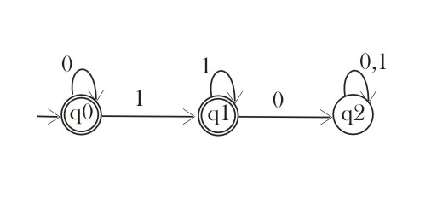

1. 01*01*
2. (01)*
3. 0*1*
4. 1*0*

11. Which of the following are the examples of non-regular languages.

1. PALINDROME and PRIME
2. PALINDROME and EVEN-EVEN
3. EVEN-EVEN and PRIME
4. FACTORIAL and SQURE

12. Languages are proved to be regular or non-regular using pumping lemma.

1. True
2. False

**Answer keys: Unit-II**

1. a
2. a
3. d
4. d
5. c
6. b
7. b
8. b
9. a
10. c
11. a
12. a

**UNIT-III:** FORMAL LANGUAGES AND REGULAR GRAMMARS

1. Noam Chomsky gave a mathematical model of a grammar in:
2. 1966
3. 1956
4. 1946
5. 1976
6. A grammar is also called a _________structured grammar.
   1. Phrase
   2. Pre
   3. Parse
   4. Class
7. The elements of VN in a grammar are called:
   1. Terminals
   2. Starting Symbols
   3. Variables
   4. Production rules
8. For any grammar G = (VN, Σ, P, S), VN ∩ Σ = __________
   1. Σ
   2. VN ∪ Σ
   3. ϴ
   4. VN
9. S in a grammar G = (VN, Σ, P, S) is called the:
   1. Stop symbol
   2. Special symbol
   3. Syntax symbol
   4. Start symbol
10. Grammatical rules which involve the meaning of words are called:
    1. Semantics
    2. Syntactic
    3. Both a and b
    4. None of given
11. Grammatical rules which do not involve the meaning of words are called:
    1. Semantics
    2. Syntactic
    3. Both a and b
    4. None of given
12. The symbols in a grammar that can’t be replaced by anything are called:
    1. Productions
    2. Terminals
    3. Non-terminals
    4. All of above
13. The symbols in a grammar that must be replaced by other things are called:
14. Productions
15. Terminals
16. Non-terminals
17. None of given
18. The grammatical rules are often called:
19. Productions
20. Terminals
21. Non-terminals
22. None of given
23. The terminals are designated by _____letters, while the non-terminals are designated by ____letters.
24. Capital, bold
25. Small, capital
26. Capital, small
27. Small, bold
28. L(G) is an acronym used for:
    1. Leaves of derivation tree for a grammar G
    2. Length of a grammar G
    3. Left hand symbols of all productions in G
    4. Language generated by a grammar G

**Answer keys: Unit-III**

1. b
2. a
3. c
4. c
5. d
6. a
7. b
8. b
9. c
10. a
11. b
12. d

**UNIT-I: FINITE AUTOMATA**

1. While minimizing a finite automata, we generally create the:
   1. Equivalence states
   2. Equivalence transitions
   3. Equivalence classes
   4. Equivalence groups
2. A Moore machine is a six-tuple (Q, Σ, Δ, δ,λ, q0) where Δ is the:
   1. Output alphabet
   2. Input alphabet
   3. Transition function
   4. Output function
3. A finite automata may contain more than one final states:
   1. True
   2. False
4. The number of columns in a transition table for a finite automata are:
   1. Three
   2. One less than the number of input symbols
   3. Same as the number of input symbols
   4. One more than the number of input symbols
5. The transition function that maps Q X Σ* into Q is called:
   1. Direct transition function
   2. Indirect transition function
   3. Simple transition function
   4. Directed transition function
6. When next state of an automata at any instant of time is determined by the present state and the present input, then it is called a:
   1. State relation
   2. Output relation
   3. Set of states
   4. Set of input symbols
7. A string x is accepted by a finite automata if δ(q0,x) = q; where q is:
   1. Initial state
   2. Final state
   3. Any state
   4. None of the above
8. Q is a set of states in finite automata. What holds true for Q:
   1. Q may contain any number of states
   2. Q contains finite number of states
   3. Q does not contain any final state
   4. Q in not a set of states.
9. Determine the Equavent Machine that takes present state and output
   1. Moore
   2. Mealy
   3. Both
   4. None
10. How many tuples are there in Finite Automata
    1. 4
    2. 5
    3. 6
    4. 7
11. Minimized automata should be
    1. DFA
    2. NFA
    3. Both
    4. None
12. Finite Automata can deal with which langauge
    1. Regular Languages
    2. Context Free
    3. Context Sensitive
    4. Recursive Ennumerable

**Answer keys: Unit-I**

1. **C**
2. **A**
3. **A**
4. **D**
5. **B**
6. **A**
7. **B**
8. **B**
9. **B**
10. **B**
11. **A**
12. **A**

**UNIT-II: REGULAR EXPRESSIONS AND REGULAR SETS**

1. In pumping lemma theorem (xyiz) the range of i is

1. i=…….-3,-2,-1, 1, 2, 3, 4……
2. i=0, 1, 2, 3, 4……….
3. i=…….-3,-2,-1, 0, 1, 2, 3, 4……
4. i=1, 2, 3, 4……….

2. To examine whether a certain FA accepts any words, it is required to seek the paths from _______state.

1. Final to initial
2. Final to final
3. Initial to final
4. Initial to initial

3. If Σ = {a,b} and given productions are

S→XaaX

X→aX| bX|Λ

Then the above grammar defines the language expressed by___________ regular expression

1. (a+b)*aa(a+b)*
2. (a+b)*a(a+b)*a
3. (a+b)*aa(a+b)*aa
4. (a+b)*aba+b)*

4. A regular expression can be defined as a language or string accepted by a finite automata.

1. True
2. False

5. If w BELONGS TO (a, b)* satisfy **abw = wab**, then (w) is

1. Null
2. Odd
3. Even
4. None of these

6. Identity: ^ + R = ________

1. ^
2. RR
3. R*
4. R

7. Identity: R + R = ________

1. 2R
2. RR
3. R
4. R*

8. Identity: (R*)* = ________

1. R**
2. R*R*
3. R*
4. R

9. The languages which can not accept PDA________

a. Regular languages

b. context free

c. context sensitive

d. none.

10. cONVERSION OF nfa TO dfa WILL LEAD TO HOW MANY INITIAL STATES

A. 2

B. 1

C. NONE

D. BOTH

11. How many strings of length less than 4 contains the language described by the regular expression (x+y)*y(a+ab)*?  
a) 7  
b) 10  
c) 12  
d) 11

12 . A language is regular if and only if  
a) accepted by DFA  
b) accepted by PDA  
c) accepted by LBA  
d) accepted by Turing machine

**Answer keys: Unit-II**

1. D
2. C
3. A
4. A
5. C
6. D
7. C
8. C
9. A
10. B
11. D
12. A

**UNIT-III: FORMAL LANGUAGES AND REGULAR GRAMMARS**

1. The highest type of grammar under Chomsky classification is:
   1. Type-3
   2. Type-4
   3. Type-2
   4. Type-0
2. Type-1 grammars are also called:
   1. Phrase structure grammars
   2. Context free grammars
   3. Context sensitive grammars
   4. Regular grammars
3. A production of the form A → a and A → aB is called a ___________ production.
   1. Type-0
   2. Type-3
   3. Type-1
   4. Type-2
4. The machine counterpart of Context Free Grammars is:
   1. Finite automata
   2. Pushdown automata
   3. Turing machine
   4. Linear bounded automata
5. The machine counterpart of Regular Grammars is:
   1. Finite automata
   2. Pushdown automata
   3. Turing machine
   4. Linear bounded automata
6. _______________is the corresponding automata for Context Sensitive languages:
   1. Linear bounded automata
   2. Turing machine
   3. Finite automata
   4. Pushdown automata
7. The symbol used for step by step derivation of a grammar is:
   1. →
   2. ⇒
   3. ↔
   4. ⇄
8. Language generated by grammar G = ( {S, C}, {a, b}, P, S ) where P consists of S → aCa, C → aCa | b is:
   1. abna
   2. anbnan
   3. abnan
   4. anban
9. Regular grammar is  
   a) Context free grammar  
   b) Non context free grammar  
   c) English grammar  
   d) None of the mentioned
10. Regular expression are  
    a) Type 0 language  
    b) Type 1 language  
    c) Type 2 language  
    d) Type 3 language
11. L and ~L are recursive enumerable then L is  
    a) Regular  
    b) Context free  
    c) Context sensitive  
    d) Recursive
12. . Regular expressions are closed under  
    a) Union  
    b) Intersection  
    c) Kleene star  
    d) All of the mentioned

**Answer keys: Unit-III**

1. a
2. c
3. b
4. b
5. a
6. a
7. b
8. d
9. a
10. a
11. d
12. d

**Unit 4 :CONTEXT FREE GRAMMARS + SIMPLIFICATION OF CONTEXT- FREE GRAMMARS**

1. The production of the form no terminal → Λ is said to be null production.
2. TRUE
3. FALSE
4. A production is called null able production if it is of the form N → Λ
5. TRUE
6. FALSE
7. The productions of the form nonterminal → one nonterminal, is called _________
8. Null production
9. Unit production
10. Null able production
11. None of given
12. CNF is stands for
13. Context Normal Form
14. Complete Normal Form
15. Chomsky Normal Form
16. Compared Null Form
17. GNF stands for
    1. Gray Normal Form
    2. Greibach Normal Form
    3. Graphite Normal Form
    4. Greatest Normal Form
18. The derivation of the word W generated by a CFG, such that at each step,a production is applied to the left most nonterminal in the working string is said to be
    1. Left most terminal
    2. Left most deviation
    3. None of these
    4. Both a and b
19. The process of finding the derivation of word generated by particular grammar is called :
    1. PLUS TIMING
    2. Parsing
    3. HALT
    4. All of above
20. A production in CFG consists of:
    1. One terminal
    2. More than one terminal
    3. One non-terminal
    4. Terminals and non-terminals
21. The entity which generate Language is termed as:  
    a) Automata  
    b) Tokens  
    c) Grammar  
    d) Data
22. The Grammar can be defined as: G=(V, ∑, p, S)  
    In the given definition, what does S represents?  
    a) Accepting State  
    b) Starting Variable  
    c) Sensitive Grammar  
    d) None of these
23. Which of the expression is appropriate?  
    For production p: a->b where a∈V and b∈_______  
    a) V  
    b) S  
    c) (V+∑)*  
    d) V+ ∑
24. For S->0S1|e for ∑={0,1}*, which of the following is wrong for the language produced?  
    a) Non regular language  
    b) 0n1n | n>=0  
    c) 0n1n | n>=1  
    d) None of the mentioned

**Answer Keys: Unit** **4**

1. a
2. a
3. b
4. c
5. b
6. b
7. b
8. d
9. C
10. B
11. C
12. d

**Unit V: PUSHDOWN AUTOMATA AND PARSING**

1. For a given Pushdown automata, we can construct an equivalent context free grammar:

1. True
2. False

2. In __________ parsing, we attempt to construct a derivation of the input string, starting from the root and ending in the given input string.

1. Top-down
2. Top-Up
3. Bottom-Up
4. Bottom-Down

3. In __________ parsing, we attempt to construct a derivation from the given input string to the top ie, the root with label S.

1. Top-down
2. Top-Up
3. Bottom-Up
4. Bottom-Down

4. In LL(k), the first L stands for__________:

1. Left
2. Look from right
3. Lost symbols
4. Look ahead

5. In LL(k), the second L stands for__________:

1. Look from right
2. Left
3. Lost symbols
4. Look ahead

6. In LL(k), k represents:

1. Number of symbols to look behind
2. Number of symbols to look ahead
3. Number of input symbols in the string
4. Number of symbols towards left of current symbol

7. In LL(k), the value of k can also be negative.

1. True
2. False

8. In order to do top-down parsing for a general string in L(G), we prepare a table called:

1. Transition table
2. Parse Table
3. Top-down Table
4. Production Table

9. The transition a Push down automaton makes is additionally dependent upon the:  
a) stack  
b) input tape  
c) terminals  
d) none of the mentioned

10.  With reference of a DPDA, which among the following do we perform from the start state with an empty stack?  
a) process the whole string  
b) end in final state  
c) end with an empty stack  
d) all of the mentioned

11. If the PDA does not stop on an accepting state and the stack is not empty, the string is:  
a) rejected  
b) goes into loop forever  
c) both (a) and (b)  
d) none of the mentioned

12. A language accepted by Deterministic Push down automata is closed under which of the following?  
a) Complement  
b) Union  
c) Both (a) and (b)  
d) None of the mentioned

**Answer keys: Unit-V**

1. a
2. a
3. c
4. d
5. b
6. b
7. b
8. b
9. a
10. d
11. a
12. a

**Unit V1: TURING MACHINES AND COMPLEXITY**

1. A Turing machine can be:

1. Multi-Tape Turing Machine
2. Multi-head Turing Machine
3. Universal Turing machine
4. All of the above

2. A Turing machine can only be deterministic.

1. True
2. False

3. A Turing machine can be a Multi-Track Turing machine.

1. True
2. False

4. Who is known as the father of Computer Science?

1. S. C. Kleene
2. Alanzo Church
3. [Charles Babbage](http://en.wikipedia.org/wiki/Charles_Babbage)
4. Alan Turing

5. A ____________ is a theoretical computing machine invented by Alan Turing (1937) to serve as an idealized model for mathematical calculation.

1. Linear Bounded Automata
2. Turing Machine
3. Finite Automata
4. Pushdown Automata

6. A Turing machine can run forever, enter a loop, or reach a particular state or set of conditions at which it is prescribed to halt.

1. True
2. False

7. In computer science, a _______________is a Turing machine that can simulate an arbitrary Turing machine on arbitrary input.

1. Universal Turing machine
2. Deterministic Turing machine
3. Non- Deterministic Turing machine
4. Multi-Tape Turing machine

8. A ________ is the simplest form of a computer.

1. Finite Automata
2. Linear Bounded Automata
3. Turing Machine
4. Pushdown Automata

9.  The machine accept the string by entering into hA or it can:  
a) explicitly reject x by entering into hR  
b) enter into an infinte loop  
c) Both (a) and (b)  
d) None of the mentioned

10. Which of the following can accept even palindrome over {a,b}  
a) Push down Automata  
b) Turing machine  
c) NDFA  
d) All of the mentioned

11. If T1 and T2 are two turing machines. The composite can be represented using the expression:  
a) T1T2  
b) T1 U T2  
c) T1 X T2  
d) None of the mentioned

12. The number of states required to automate the last question i.e. {a,b}*{aba}{a,b}* using finite automata:  
a) 4  
b) 3  
c) 5  
d) 6

**Answer Keys: Unit V1**:

1. d
2. b
3. a
4. d
5. b
6. a
7. a
8. c
9. c
10. c
11. a
12. a

Q1 Which of the following pairs of regular expressions are equivalent?  
a) 1(01)* and (10)*1  
b) x (xx)* and (xx)*x  
c) x^+ and x^+ x^(*+)  
**d) All of the mentioned**

**Q2** What is the Regular Expression Matching Zero or More Specific Characters  
a) x  
b) #  
**c) \***  
d) &

Q3 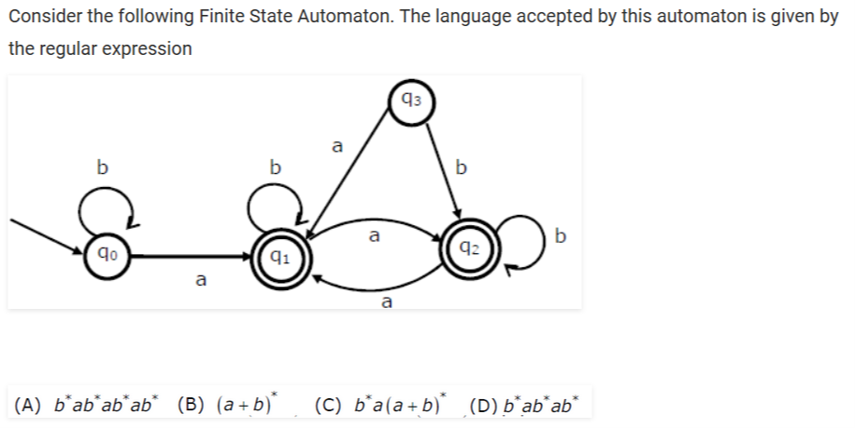

Ans. C

Q4

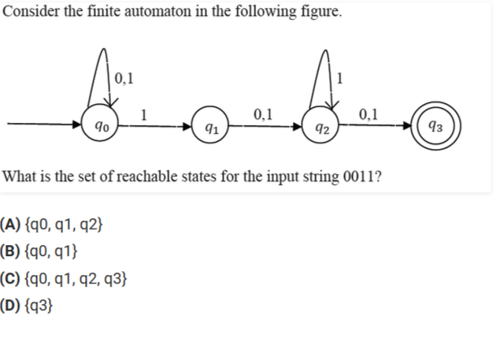

Ans. A

Q5

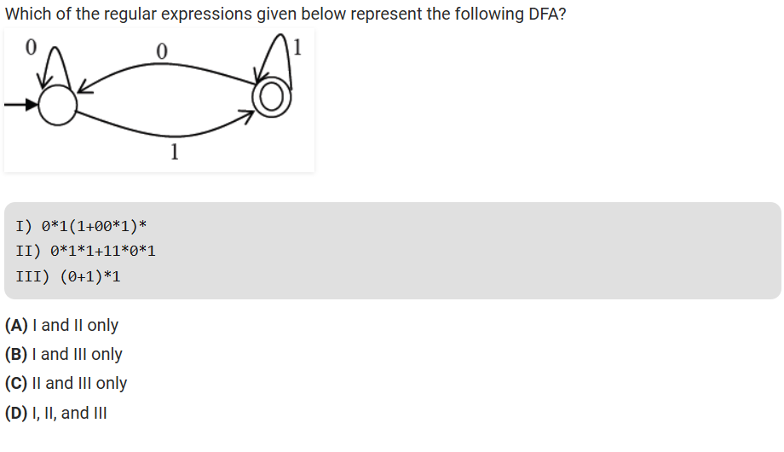

Ans. B

Q6

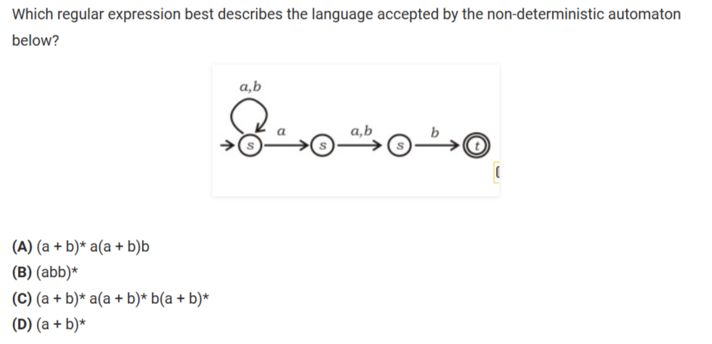

Ans. A

Q7 Consider the two automata

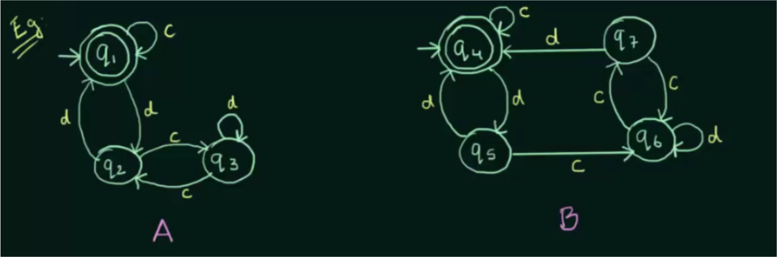

1. A and B are Equivalent
2. A and B are not Equivalent
3. Cannot be defined
4. None of these

Ans.A

Q8 Regular expression (x/y)(x/y) denotes the set

a. {xy,xy}

b. {xx,xy,yx,yy}

c. {x,y}

d. {x,y,xy}

Ans.b

Q9 The regular expression with all strings of 0′s and 1′s with at least two consecutive 0′s is:

a. 1 + (10)*

b. (0+1)*00(0+1)*

c. (0+1)*011

d. 0*1*2*

Ans. B

Q10 Find the pair of regular expressions that are equivalent

a. (0+1)* and (0*+1*)*

b. (0+1)* and (0+1*)*

c. (0+10)* and (0*+10)*

d. All of the mentioned

Ans. D

Q11

|  |
| --- |
| Which of the following is same as the given DFA?  https://compscibits.com/QuestionImages/62746-1.png |
|  |
| 1. (0+1)*001(0+1)* |  |
| 1. 1*001(0+1)* |  |
| 1. (01)*(0+0+1)(01)* |  |
| 1. None of the mentioned |  |

Ans. A

Q12

|  |
| --- |
| Which of the given regular expressions correspond to the automata shown?  https://compscibits.com/QuestionImages/62747-1.png |
|  |  |

a. (110+1)*0

b. (11+110)*1

c. (110+11)*0

d. (1+110)*1

Ans. C

Q13 Which among the following looks similar to the given expression?

((0+1). (0+1)) *

a. {xϵ {0,1} *|x is all binary number with even length}

b. {xϵ {0,1} |x is all binary number with even length}

c. {xϵ {0,1} *|x is all binary number with odd length}

d. {xϵ {0,1} |x is all binary number with odd length}

Ans. A

Q14 (a + b*c) most correctly represents:

a. (a +b) *c

b. (a)+((b)*.c)

c. (a + (b*)).c

d. a+ ((b*).c)

Ans. D

Q15

|  |
| --- |
| Which NDFA correctly represents the following RE   a(bab)*∪a(ba)*  non deterministic finite automata |
| **Ans. a** |  |

Q16 Which of the following does the given NFA represent?



a. {11, 101} * {01}

b. {110, 01} * {11}

c. {11, 110} * {0}

d. {00, 110} * {1}

ans. C

Question 1: While applying Pumping lemma over a language, we consider a string w that belong to L and fragment it into _________ parts.

a) 2

b) 5

c) 3

d) 6

Ans: c

Question 2: If we select a string w such that w∈L, and w=xyz. Which of the following portions cannot be an empty string?

a) x

b) y

c) z

d) all of the mentioned

Ans: b

Question 3: There exists a language L. We define a string w such that w∈L and w=xyz and |w| >=n for some constant integer n.What can be the maximum length of the substring xy i.e. |xy|<=?

a) n

b) |y|

c) |x|

d) none of the mentioned

Ans: a

Question 4: Fill in the blank in terms of p, where p is the maximum string length in L.

Statement: Finite languages trivially satisfy the pumping lemma by having n = ______

a) p*1

b) p+1

c) p-1

d) None of the mentioned

Ans: b

Question 5: Let w be a string and fragmented by three variable x, y, and z as per pumping lemma. What does these variables represent?

a) string count

b) string

c) both (a) and (b)

d) none of the mentioned

Ans: a

Question 6: Which of the following is not an application of Pumping Lemma?

a) {0i1i|i>=0}

b) {0ix|i>=0, x∈{0, 1}* and |x|<=i}

c) {0n| n is prime}

d) None of the mentioned

Ans: d

Question 7: Pumping lemma method is used to geneate ....... from .........

a) (i) many input strings (ii) one string

b) (i) one string (ii) many input strings

c) Either a or b

d) None of the mentioned

Ans: a

Question 8: Amongst the various pairs, which pair is taken in the pumping lemma

a) 1st

b) 2nd

c) 4th

d) None of the mentioned

Ans: a

Question 9: Let w= xyz and y refers to the middle portion and |y|>0.What do we call the process of repeating y 0 or more times before checking that they still belong to the language L or not?

a) Generating

b) Pumping

c) Producing

d) None of the mentioned

Ans: b

Question 10: Answer in accordance to the third and last statement in pumping lemma:

For all _______ xyiz ∈L

a) i>0

b) i<0

c) i<=0

d) i>=0

Ans: d

Question 11: Which of the technique can be used to prove that a language is non regular?

a) Ardens theorem

b) Pumping Lemma

c) Ogden’s Lemma

d) None of the mentioned

Ans: b

Question 12: If L1′ and L2′ are regular languages, then L1.L2 will be

a) regular

b) non regular

c) may be regular

d) none of the mentioned

Ans: a

Question 13: If L1 and L2′ are regular languages, L1 ∩ (L2′ U L1′)’ will be

a) regular

b) non regular

c) may be regular

d) none of the mentioned

Ans: a

Question 14: If A and B are regular languages, !(A’ U B’) is:

a) regular

b) non regular

c) may be regular

d) none of the mentioned

Ans: a

Question 15: Which among the following is the closure property of a regular language?

a) Emptiness

b) Universality

c) Membership

d) None of the mentioned

Ans: d

1. There are ________ tuples in finite state machine.  
   a) 4  
   b) 5  
   c) 6  
   d) unlimited

Ans:- B

1. Transition function maps.  
   a) Σ * Q -> Σ  
   b) Q * Q -> Σ  
   c) Σ * Σ -> Q  
   d) Q * Σ -> Q

Ans: - d

1. Number of states requires accepting string ends with 10.  
   a) 3  
   b) 2  
   c) 1  
   d) can’t be represented.

Ans:-a

1. Number of final state requires accepting Φ in minimal finite automata.  
   a) 1  
   b) 2  
   c) 3  
   d) None of the mentioned

Ans:-d

1. Number of states requires in NFA simulating a computer with memory capable of storing ‘3’ words each of length ‘8’.  
   a) 3 * 28  
   b) 2(3*8)  
   c) 2(3+8)  
   d) None of the mentioned

Ans:- b

1. An NFA’s transition function returns

a. A Boolean value

b. A state

c. A set of states

d. An edge

Ans:C

7. The behaviour of a NFA can be stimulated by DFA

a. Always

b. Sometimes

c.Never

d. Depends on NFA

Ans:-a

8. The relation between NFA-accepted languages and DFA accepted languages is

a. >

b.<

c.=

d.<=

Ans:- c

9. Examine the following DFA: If input is 011100101, which edge is NOT traversed?

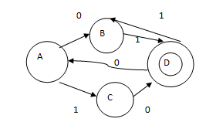

a. A B

b. C

c. C D

d. D A

Ans:- C

10. The transitional function of a NFA is

a. Q X Σ→Q

b. Q X Σ→2Q

c. Q X Σ→2n

d.Q X Σ→Qn

Ans:- B

11. Which is true for Dead State?

a. It cannot be reached anytime

b. There is no necessity of the state

c. If control enters no way to come out from the state

d.If control enters FA deads

Ans:- C

12. Which among the following states would be notated as the final state/acceptance state?   
  
L= {xϵ∑= {a, b} | length of x is 2}

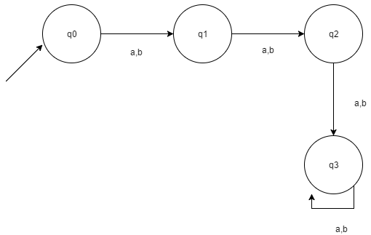

a. q1

b. q2

c. q1, q2

d. q3

Ans:- b

13. Which of the following are the final states in the given DFA according to the Language given ?   
L= {xϵ∑= {a, b} |length of x is at most 2}



a. q0, q1

b. q0, q2

c.q1, q2

d. q0, q1, q2

Ans:D

14. Which of the following x is accepted by the given DFA (x is a binary string ∑= {0,1})?



a. divisible by 3

b. divisible by 2

c. divisible by 2 and 3

d. divisible by 3 and 2

Ans:- d

15. Choose the correct option for the given statement:   
  
Statement: The DFA shown represents all strings which has 1 at second last position.

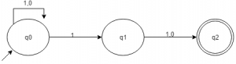

a. Correct

b. Incorrect, Incomplete DFA

c. Wrong proposition

d. May be correct

**MCQ’s on regular languages and regular expressions**

1. A language is regular if and only if

a) **accepted by DFA**

b) accepted by PDA

c) accepted by LBA

d) accepted by Turing machine

2. Regular grammar is

a) **context free grammar**

b) non context free grammar

c) english grammar

d) none of the mentioned

3. Regular expression are

a) **Type 0 language**

b) Type 1 language

c) Type 2 language

d) Type 3 language

4. Consider the languages L1=ɸ and L2 = {a}. Which one of the following represents L1 L2* U L1*



1. **A**
2. B
3. C
4. D

5. Given the language L = {ab, aa, baa}, which of the following strings are in L*?

1) abaabaaabaa

2) aaaabaaaa

3) baaaaabaaaab

4) baaaaabaa

a) 1, 2 and 3

b) 2, 3 and 4

c) **1, 2 and 4**

d) 1, 3 and 4

6. Let w be any string of length n is {0,1}*. Let L be the set of all substrings of w. What is the minimum number of states in a non-deterministic finite automaton that accepts L?

a) n-1

b) n

c) **n+1**

d) 2n-1

7. Which one of the following languages over the alphabet {0,1} is described by the regular expression: (0+1)*0(0+1)*0(0+1)*?

a) The set of all strings containing the substring 00

b) The set of all strings containing at most two 0’s

c) **The set of all strings containing at least two 0’s**

d) The set of all strings that begin and end with either 0 or 1.

8. The regular expression 0*(10*)* denotes the same set as

a) **(1*0)*1\***

b) 0 + (0 + 10)*

c) (0 + 1)* 10(0 + 1)*

d) none of these

9. The smallest finite automation which accepts the language {x | length of x is divisible by 3} has :

a) 2 states

b) **3 states**

c) 4 states

d) 5 states

10. Consider the following languages

 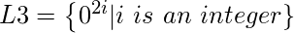 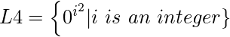

Which of the languages are regular?

1. Only L1 and L2
2. Only L2, L3 and L4
3. Only L3 and L4
4. **Only L3**

Q1) Consider the languages L1 =  and L2 = {a}. Which one of the following represents L1 L2* U L1*

a){ epsilon } b) a* c){epsilon,a} d)none

Answer: A

Q2)

[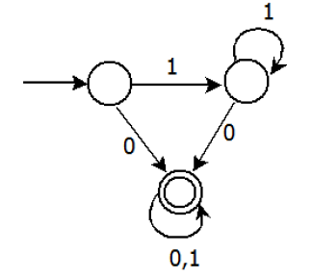](http://www.geeksforgeeks.org/wp-content/uploads/gq/2013/10/gatecs201313.png)

Consider the DFA given.  Which of the following are FALSE?

1. Complement of L(A) is context-free.

2. L(A) = L((11*0+0)(0 + 1)*0*1*)

3. For the language accepted by A, A is the minimal DFA.

4. A accepts all strings over {0, 1} of length at least 2.

Answer: 3 and 4

Q3) Given the language L = {ab, aa, baa}, which of the following strings are in L*?

1) abaabaaabaa

2) aaaabaaaa

3) baaaaabaaaab

4) baaaaabaa

Answer : 1,2,4

Q4) Find the regular expression for the given

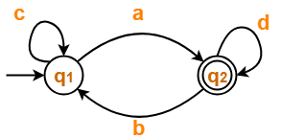

Answer : **c*a(d+bc*a)\***

**Q5)** Find the regular expression for the given

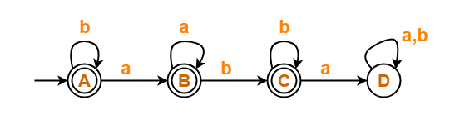

Answer: **b*(aa*(bb*+∈)+∈)**

**Q6)** Find the regular expression for the given

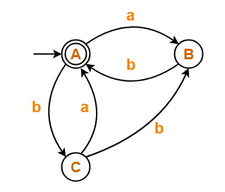

Answer: **(ab + b(a+bb))\***

**Q7)** Find the regular expression for the given

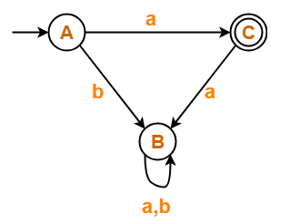

Answer: regular expression is only **a, because state B is dead state.**

**Q8)** Find the regular expression for the given

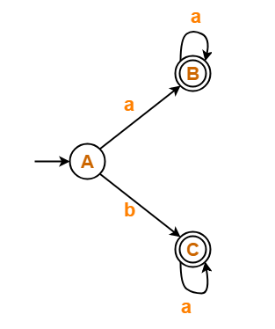

**Answer:** **aa* + ba\***

**Q9)** A regular language over an alphabet a is one that can be obtained from  
a) union  
b) concatenation  
c) kleene  
d) All of the mentioned

**Answer: d**

**Q10)**

Regular expression Φ* is equivalent to  
a) ϵ  
b) Φ  
c) 0  
d) 1

Answer:A

Q: 1 How many states are require to construct a minimal dfa from the given DFA

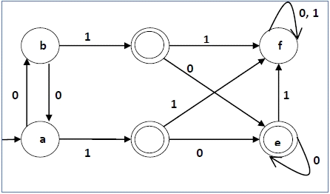

a)2 b)3 c)4 d)5

2.From the given DFA which string is accepted

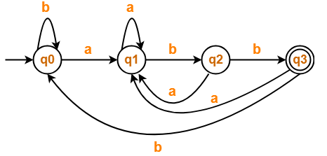

a) abbabb b) abbabba c) aabba d) aaba

ans a

3.Which DFA is accept the string in which every a is followed by b where Σ = {a,b} .

a)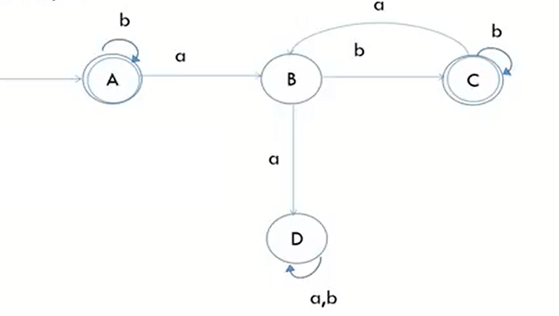

b) [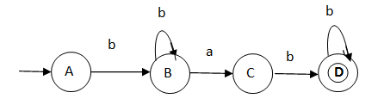](https://www.google.co.in/url?sa=i&rct=j&q=&esrc=s&source=images&cd=&ved=2ahUKEwjx56HZgObjAhUdiHAKHamxCsoQjRx6BAgBEAU&url=https://www.quora.com/How-can-I-construct-finite-automata-in-which-a-is-immediately-preceded-and-followed-by-b&psig=AOvVaw0S0isZHnOUK9qMI_zu5Pqz&ust=156489748241814)

c) [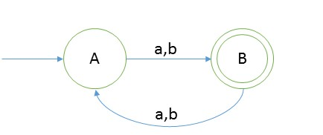](https://www.google.co.in/url?sa=i&rct=j&q=&esrc=s&source=images&cd=&ved=2ahUKEwiH5djogObjAhUPknAKHXwQAdQQjRx6BAgBEAU&url=http://scanftree.com/automata/dfa-string-example-1&psig=AOvVaw0S0isZHnOUK9qMI_zu5Pqz&ust=156489748241814)   
d) None of these

4.

|  |
| --- |
| 9.)Consider the finite automaton in the following figure. What is the set of reachable states for the input string 0011 ?  Image |
| **a.** q0, q1,q2 |
| **b.** q0,q1 |
| **c.** q0,q1,q2,q3 |
| **d.** q3 |

5.What the following DFA accepts?  
[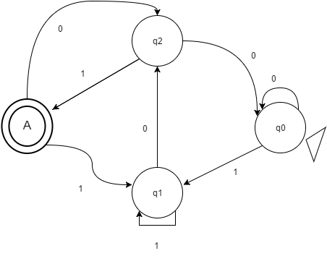](https://www.sanfoundry.com/wp-content/uploads/2017/05/automata-theory-interview-questions-answers-q4.pn)  
a) x is a string such that it ends with ‘101’  
b) x is a string such that it ends with ‘01’  
c) x is a string such that it has odd 1’s and even 0’s  
d) x is a strings such that it has starting and ending character as 1

6. Minimize the dfa below given transition table

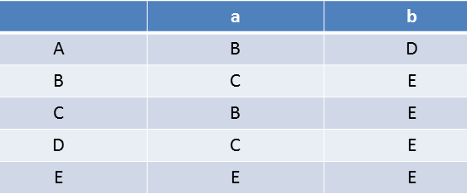

a) 3 b)4 c)2 d)5

7.How many states are required after construct a minimal DFA

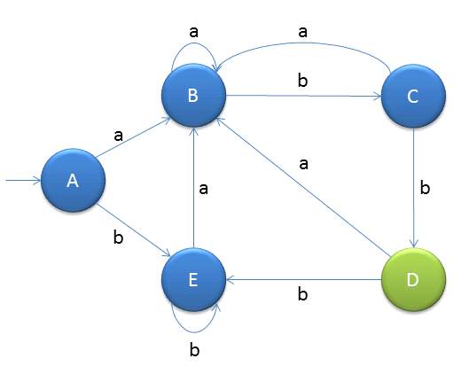

A)3 B)2 C)5 D)4

8)Statement 1: Acceptance of string only when it goes to first state to final state .

statement 2: String is accepted only when it statisfy the language .

a) Statement 1 is correct , Statement 2 is correct .

b) Statement 1 is not correct , Statement 2 is correct .

c) Statement 1 is correct , Statement is not correct

d) Statement 1 is not correct , statement 2 is not correct

9) At which state String 'aa' accepted

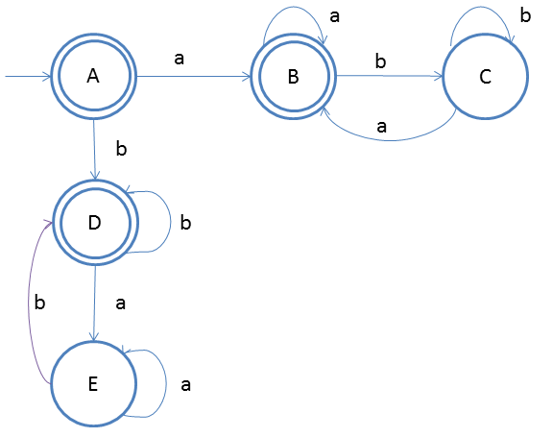

a) D b) A c) B d) C

10) How many states after Minimize the below dfa

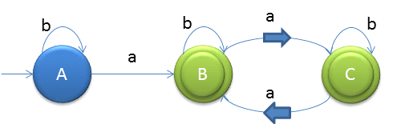

a) 3 b) 2 c) 4 d) 5

11) Which state is accepted String '110101'

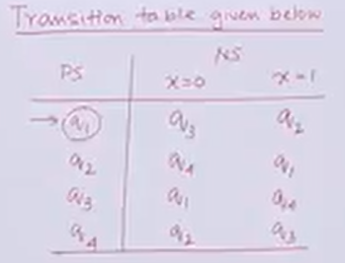

a) q2 b) q3 c) q1 d) q4

12) Minimize given dfa

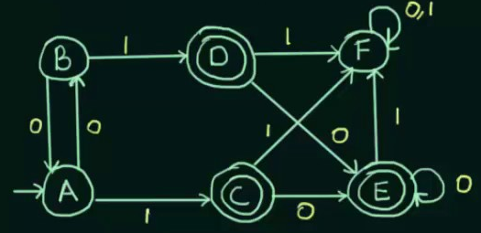

a) {A,B,} {F} ,{C,D,E}

b){A,F},{B},{C,D,E}

C){A} {B,F} {C,D,E}

D){A,B,F){C,D,E}

13.) Given the language L = {ab, aa, baa}, which of the following strings are in L*?

1) abaabaaabaa

2) aaaabaaaa

3) baaaaabaaaab

4) baaaaabaa

a)1, 2 and 3

b)2, 3 and 4

c)1, 2 and 4

d)1, 3 and 4

14.)Let w be any string of length n is {0,1}*. Let L be the set of all substrings of w. What is the minimum number of states in a non-deterministic finite automaton that accepts L?

A )n-1

b)n

c)n+1

D)2n-1

15) Which string is accepted by DFA

a) an

b) anbn

c) anbncn

1) a ,b 2) c 3) a,b,c 4) a

1. A language is regular if and only if  
   a) accepted by DFA  
   b) accepted by PDA  
   c) accepted by LBA  
   d) accepted by Turing machine

Answer- a

1. Regular grammar is

a. context free grammar

b. non context free grammar

c. English grammar

d. none of the mentioned

Answer- a

3. Regular expression are

a. Type 0 language

b. Type 1 language

c. Type 2 language

d. Type 3 language

4. Regular languages are closed under (closure properties)

a. Concatenation

b. Union

c. Complement

d. All of the above

Answer- d

5. If L1 is regular, then there exists some regular expression r1 which describes it. Same for L2. Then:L1 U L2 = L(r1) U L(r2) = r1 + r2

r1 + r2 is a regular expression and therefore describes a regular language.

1. True
2. False

Answer : a

6. If L1 = {an | n ≥ 0} and L2 = {bn | n ≥ 0} is regular  
then L3 = L1.L2 = {am . bn | m ≥ 0 and n ≥ 0} is also regular?

a. False

b True

Answer b

7. Which one of the following languages over the alphabet {0,1} is described by the regular expression?  
(0+1)*0(0+1)*0(0+1)*  
a. The set of all strings containing the substring 00.  
b. The set of all strings containing at most two 0’s.

c. The set of all strings containing at least two 0’s.  
d. The set of all strings that begin and end with either 0 or 1.

Answer c

8. A language is regular if it can be expressed in terms of ……………..

a. Regular expression

b. Type 0 Language

c. English Grammer

g. None of the above

Answer a

9. Which of the following pairs of regular expressions are equivalent?

a. 1(01)* and (10)*1

b. x (xx)* and (xx)*x

c. x^+ and x^+ x^(*+)

d. All of the above mentioned

Answer d

10. Regular expressions are used to represent which language

a) Recursive language

b) Context free language

c) Regular language

d) All of these

Answer c

11. Which of the following operation can be applied on regular expressions?

a) Union

b) Concatenation

c) Closure

d) All of these

answer d

12. 7. Which of the following identity is wrong?

a) R + R = R

b) (R*)* = R*

c) ɛR = Rɛ = R

d) ØR = RØ = RR*

Answer d

13. Which of the following statement is true?

a) Every language that is defined by regular expression can also be defined by finite automata

b) Every language defined by finite automata can also be defined by regular expression

c) We can convert regular expressions into finite automata

d) All of these

Answer d

14. Which of the following identity is true?

a) ɛ +RR* = R* = ɛ + R*R

b) (R1R2)*R1 = R1(R2R1)*

c) R*R* = R*

d) All of these

15.  (a+b)* is equivalent to  
a) b*a*  
b) (a*b*)*  
c) a*b*  
d) none of the mentioned

Answer b

16. Consider a finite automaton, with A-moves, given in Fig. which among the following is the

Equivalent automaton without A-moves.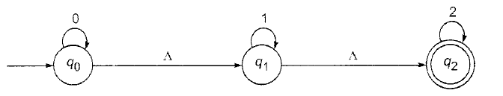

1. 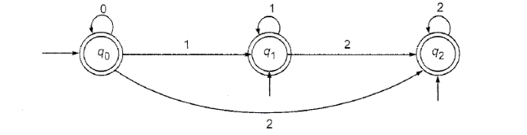
2. 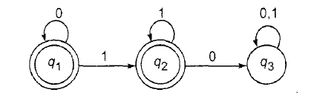
3. 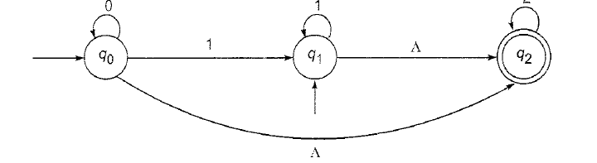
4. None of above

Answer a

17. Suppose we want to replace a null move from vertex V1 to vertex V2 in FAThen

What is the first step needs to be done:

1. Make a new vertex V3
2. Find all the edges starting from *v2*
3. Delete Vertex V2
4. None of the above

Answer b

A context sensitive language is accepted by

a) Finite automata

b) Linear bounded automata

c) Both (a) and (b)

d) None of these

Ans- B

A grammar G = (V, T, P, S) in which V is

a) Set of variables

b) Set of terminals

c) Set of variables and terminals

d) None of these

Ans-A

A grammar G = (V, T, P, S) in which T is

a) Set of variables

b) Set of terminals

c) Set of variables and terminals

d) None of these

Ans- B

Which of the following is more powerful?

a) PDA

b) Turing machine

c) Finite automata

d) Context sensitive language

Ans-B

Which of the following string is generated by the grammar

S -> 0S1AB

A -> 4A

B -> SA

a) 0111

b) 010101

c) 00000

d) None of these

 Which of the following relates to Chomsky hierarchy?  
a) Regular<CFL<CSL<Unrestricted  
b) CFL<CSL<Unrestricted<Regular  
c) CSL<Unrestricted<CF<Regular  
d) None of the mentioned

Ans-a

A language is accepted by a push down automata if it is:  
a) regular  
b) context free  
c) both (a) and (b)  
d) none of the mentioned

Ans- B

Which of the following strings do not belong the given regular expression?  
(a)*(a+cba)  
a) aa  
b) aaa  
c) acba  
d) acbacba

Ans-d

**Which of the following CFG's can't be simulated by an FSM ?**

|  |  |
| --- | --- |
| [**A.**](javascript:void(0);) | S --> Sa | b |
| [**B.**](javascript:void(0);) | S  --> aSb | ab |
| [**C.**](javascript:void(0);) | S --> abX,  X --> cY,  Y --> d | aX |
| [**D.**](javascript:void(0);) | None of these |

Ans-B

Regular Grammar is accepted by

1. FA
2. LBA
3. Turing Machine
4. All

Q. If Σ = {a,b} and given productions are

S→XaaX

X→aX| bX|Λ

Then the above grammar defines the language expressed by___________ regular expression

1. (a+b)*aa(a+b)*
2. (a+b)*a(a+b)*a
3. (a+b)*aa(a+b)*aa
4. (a+b)*aba+b)*

Ans-A

Q. The languages which can not accept PDA________

a. Regular languages

b. context free

c. context sensitive

d. none.

Ans- C

Q Regular grammar is  
a) Context free grammar  
b) Non context free grammar  
c) English grammar  
d) None of the mentioned

Ans- A

Regular expression are  
a) Type 0 language  
b) Type 1 language  
c) Type 2 language  
d) Type 3 language

Ans- A

L and ~L are recursive enumerable then L is  
a) Regular  
b) Context free  
c) Context sensitive  
d) Recursive

Ans-D

Regular expressions are closed under  
a) Union  
b) Intersection  
c) Kleene star  
d) All of the mentioned

Ans-d

How many strings of length less than 4 contains the language described by the regular expression (x+y)*y(a+ab)*?  
a) 7  
b) 10  
c) 12  
d) 11

Ans-D

Grammatical rules which involve the meaning of words are called:

* 1. Semantics
  2. Syntactic
  3. Both a and b
  4. None of given

Ans- A

Grammatical rules which do not involve the meaning of words are called:

1. Semantics
2. Syntactic
3. Both a and b
4. None of given

Ans-B

The symbols in a grammar that can’t be replaced by anything are called:

1. Productions
2. Terminals
3. Non-terminals
4. All of above

Ans-B

The symbols in a grammar that must be replaced by other Synbols are called:

1. Productions
2. Terminals
3. Non-terminals
4. None of given

Ans-C

Q1. Consider the languages L1 = ᶲ and L2 = {a}. Which one of the following represents

L1 L2* U L1

**a) {€}** b)ᶲ c) a* d) {€,a}

Q2. Let S and T be language over ={a,b} represented by the regular expressions (a+b*)*

and (a+b)*, respectively. Which of the following is true?

(a) ScT (S is a subset of T)

(b) TcS (T is a subset of S)

**(c) S=T**

(d) SnT=Ø

Q3. Let L denotes the language generated by the grammar S – OSO/00. Which of the

following is true?

(a) L = O

**(b) L is regular but not O**

(c) L is context free but not regular

(d) L is not context free

Q4. Consider the following two statements:

S1: { 0^2n |n >= l} is a regu1ar language

S2: { 0^m 0^n 0^(m+n) l m >= 1 and n >= 2} is a regu1ar language

Which of the following statements is correct? (GATE CS 2001)

a) Only S1 is correct

b) Only S2 is correct

**c) Both S1 and S2 are correct**

d) None of S1 and S2 is correct

Q5. Which of the following statements in true? (GATE CS 2001)

(a) If a language is context free it can always be accepted by a deterministic push-down

automaton

**(b) The union of two context free languages is context free**

(c) The intersection of two context free languages is context free

(d) The complement of a context free language is context free

Q6. Given an arbitrary non-deterministic finite automaton (NFA) with N states, the

maximum number of states in an equivalent minimized DFA is at least. (GATE CS 2001)

(a) N^2

**(b) 2^N**

(c) 2N

(d) N!

Q7. Given the language L = {ab, aa, baa}, whih of the following strings are in L*?

1) abaabaaabaa

2) aaaabaaaa

3) baaaaabaaaab

4) baaaaabaa

(A) 1, 2 and 3

(B) 2, 3 and 4

**(C) 1, 2 and 4**

(D) 1, 3 and 4

8. Which of the following problems are decidable?

….1) Does a given program ever produce an output?

….2) If L is a context-free language, then is L’ (complement of L) also context-free?

….3) If L is a regular language, then is L’ also regular?

….4) If L is a recursive language, then, is L’ also recursive?

(A) 1, 2, 3, 4

(B) 1, 2,

(C) 2, 3, 4

**(D) 3, 4**

9. Let P be a regular language and Q be context-free language such that Q ⊆ P. (For

example, let P be the language represented by the regular expression p*q* and Q be

{pnqn

|n ∈ N}). Then which of the following is ALWAYS regular?

(A) P ∩ Q

(B) P – Q

**(C) ∑* – P**

(D) ∑* – Q

10. (a+b)* is equivalent to

a) b*a*

**b) (a*b*)\***

c) a*b*

d) none of the mentioned

11. a? is equivalent to

a) a

b) a+Φ

**c) a+ϵ**

d) wrong expression

12. Regular expression Φ* is equivalent to

**a) ϵ**

b) Φ

c) 0

d) 1

13. A language is regular if and only if

**a) accepted by DFA**

b) accepted by PDA

c) accepted by LBA

d) accepted by Turing machine

14. Let the class of language accepted by finite state machine be L1 and the class of languages

represented by regular expressions be L2 then

a) L1<L2

b) L1>=L2

c) L1 U L2 = .*

**d) L1=L2**

15. Regular expression {0,1} is equivalent to

a) 0 U 1

b) 0 / 1

c) 0 + 1

**d) All of the mentioned**

1. Transition function of DFA maps.  
   a) Σ * Q -> Σ  
   b) Q * Q -> Σ  
   c) Σ * Σ -> Q  
   d) Q * Σ -> Q

Answer: d

1. Minimum Number of states require to accept string ends with 10.  
   a) 3  
   b) 2  
   c) 1  
   d) can’t be represented.

Answer: a

1. δ*(q,ya) is equivalent to .  
   a) δ((q,y),a)  
   b) δ(δ*(q,y),a)  
   c) δ(q,ya)  
   d) independent from δ notation

Answer: b

1. Languages of a automata is  
   a) If it is accepted by automata  
   b) If it halts  
   c) If automata touch final state in its life time  
   d) All language are language of automata

Answer: a

1. Finite automata requires minimum _______ number of stacks.  
   a) 1  
   b) 0  
   c) 2  
   d) None of the mentioned

Answer: b

1. FSM with output capability can be used to add two given integer in binary representation. This is  
   a) True  
   b) False  
   c) May be true  
   d) None of the mentioned

Answer: a

1. If NFA of 6 states excluding the initial state is converted into DFA, maximum possible number of states for the DFA is ?  
   a) 64  
   b) 32  
   c) 128  
   d) 127

Answer: c

1. NFA, in its name has ’non-deterministic’ because of :  
   a) The result is undetermined  
   b) The choice of path is non-deterministic  
   c) The state to be transited next is non-deterministic  
   d) All of the mentioned

Answer: b

1. The construction time for DFA from an equivalent NFA (m number of node)is:  
   a) O(m2)  
   b) O(2m)  
   c) O(m)  
   d) O(log m)

Answer: b

1. Which of the following option is correct?  
   a) NFA is slower to process and its representation uses more memory than DFA  
   b) DFA is faster to process and its representation uses less memory than NFA  
   c) NFA is slower to process and its representation uses less memory than DFA  
   d) DFA is slower to process and its representation uses less memory than NFA

Answer: c

1. Choose the correct option for the given statement:  
   Statement: The DFA shown represents all strings which has 1 at second last position.

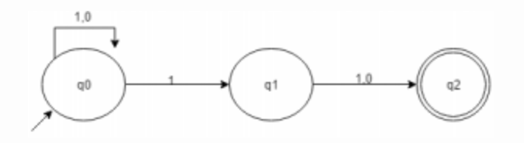a) Correct  
b) Incorrect, Incomplete DFA  
c) Wrong proposition  
d) May be correct

Answer: c

**TOC mcq**

**Definition and description of FA:**

1. NFA, in its name has ’non-deterministic’ because of :  
a) The result is undetermined  
b) The choice of path is non-deterministic  
c) The state to be transited next is non-deterministic  
d) All of the mentioned  
Answer: b

2. Languages of a automata is  
a) If a string is accepted by automata  
b) If it halts  
c) If automata touch final state in its life time  
d) All language are language of automata  
Answer: a

3. The basic limitation of finite automata is that  
a) It can’t remember arbitrary large amount of information.  
b) It sometimes recognize grammar that are not regular.  
c) It sometimes fails to recognize regular grammar.  
d) All of the mentioned  
Answer:a

4. What the following DFA accepts?  
[](https://www.sanfoundry.com/wp-content/uploads/2017/05/automata-theory-interview-questions-answers-q4.png)  
a) x is a string such that it ends with ‘101’  
b) x is a string such that it ends with ‘01’  
c) x is a string such that it has odd 1’s and even 0’s  
d) x is a strings such that it has starting and ending character as 1

Answer A)

5. What does the following figure most correctly represents?  
[](https://www.sanfoundry.com/wp-content/uploads/2017/05/automata-theory-interview-questions-answers-q6.png)  
a) Final state with loop x  
b) Transitional state with loop x  
c) Initial state as well as final state with loop x  
d) Insufficient Data  
Answer: c

6. Number of final state requires to accept Φ in minimal finite automata.  
a) 1  
b) 2  
c) 3  
d) None of the mentioned

Answer:d  
Explanation: No final state requires.

7. Which of the following is an application of Finite Automaton?  
a) Compiler Design  
b) Grammar Parsers  
c) Text Search  
d) All of the mentioned  
Answer: d

8. Which DFA is correct for the given Language: accepting string ending with '01' over input alphabets ∑={a.b}

a) 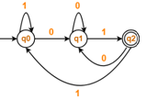b) [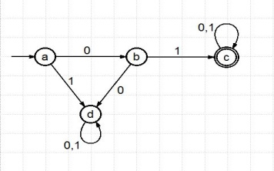](https://www.google.co.in/url?sa=i&rct=j&q=&esrc=s&source=images&cd=&ved=2ahUKEwjm9aDi9-XjAhVM6Y8KHb66B-cQjRx6BAgBEAU&url=http://csenzyme.blogspot.com/2015/05/design-dfa-which-will-accept-all_27.html&psig=AOvVaw3VTnnXe21MF7eMUgOatguP&ust=1564895381493047) c) [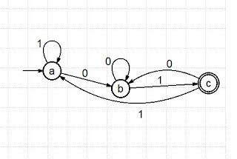](https://1.bp.blogspot.com/-AA2iY8W75Qk/WDyCXIXDERI/AAAAAAAATrA/4SWKeEhTEukArJceyGs_TmnXVmE68rVAgCLcB/s1600/aaj.JPG) d) None of these Ans c

9. How many Final states in the given language : {an | where n >=1 but n ≠ 2,6 } , Σ= {a}

a) 2 b) 4 c) 3 d) 6 Ans b)

10. Transition function maps.  
a) Σ * Q -> Σ  
b) Q * Q -> Σ  
c) Σ * Σ -> Q  
d) Q * Σ -> Q Ans d)

11. Finite automata has only

a) Finite memory

b) Read only head

c) Finite control

d) All of them Ans d)

**The Equivalence of deterministic and non-deterministic finite automata**

12. The relation between NFA-accepted languages and DFA accepted languages is  
a) >  
b) <  
c) =  
d) <= Ans c)

13. Which of the following is correct proposition?  
Statement 1: Non determinism is a generalization of Determinism.  
Statement 2: Every DFA is automatically an NFA

a) Statement 1 is correct because Statement 2 is correct  
b) Statement 2 is correct because Statement 2 is correct  
c) Statement 2 is false and Statement 1 is false  
d) Statement 1 is false because Statement 2 is false Ans a)

14. Which NFA is correct for the transition table as given below:

|  |  |  |
| --- | --- | --- |
| **Present State** | **0** | **1** |
| →q0 | q0, q1 | q0, q2 |
| q1 | q3 | ε |
| q2 | q2, q3 | q3 |
| →q3 | q3 | q3 |

a) 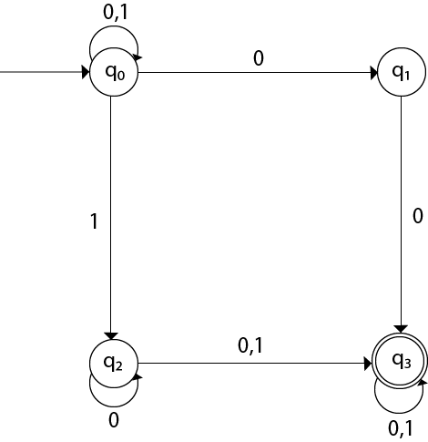 b) 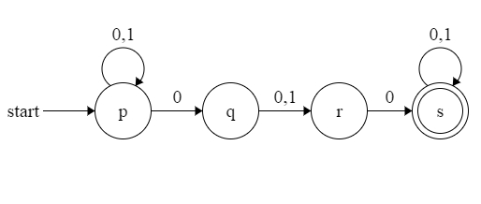

c) 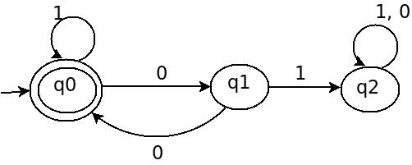 d) None of these Ans a)

15. Given a NFA with N states, the maximum number of states in an equivalent minimized DFA is at least

a) N^2

b) 2^N

c) 2N

d) N! Ans b)

Q1 What is wrong in the given definition?  
Def: ({q0, q1, q2}, {0,1}, δ, q3, {q3})  
a) The definition does not satisfy 5 Tuple definition of NFA  
b) There are no transition definition  
c) Initial and Final states do not belong to the Graph  
d) Initial and final states can’t be same

**Answer: c**

Q2) Number of states require to accept string ends with 10.

a) 3

b) 2

c) 1

d) can’t be represented.

**Answer: a**

Q3) δ(q,ya) is equivalent to .

a) δ((q,y),a)

b) δ(δ(q,y),a)

c) δ(q,ya)

d) independent from δ notation

**answer: b**

Q4 Finite automata requires minimum _______ number of stacks.

a) 1

b) 0

c) 2

d) None of the mentioned

**answer: b**

Q 5 An NFA’s transition function returns

a. A Boolean value

b. A state

c. A set of states

d. An edge

**answer: c**

**Q6**  Choose the correct option for the given statement:  
Statement: The DFA shown represents all strings which has 1 at second last position.  
[](https://www.sanfoundry.com/wp-content/uploads/2017/05/automata-theory-questions-answers-extended-transition-function-q2.png)  
a) Correct  
b) Incorrect, Incomplete DFA  
c) Wrong proposition  
d) May be correct

**Answer: c ( bcz it is nfa)**

Q7. Which of the following is a not a part of 5-tuple finite automata?  
a) Input alphabet  
b) Transition function  
c) Initial State  
d) Output Alphabet

**Answer: d**

Q8)Transition function maps.

a) Σ * Q -> Σ

b) Q * Q -> Σ

c) Σ * Σ -> Q

d) Q * Σ -> Q

**Answer: d**

Q9 The sum of minimum and maximum number of final states for a DFA having ‘n’ states is equal to:

a)n+1

b)n

c) n-2

d) n+2

**answer : a**

Q 10 The maximum number of transitions which can be performed over a state in a DFA using Σ={a,b,c} ?

a)1

b)2

c)3

d) 4

**answer : c**

5. Given an arbitrary non-deterministic finite automaton (NFA) with N states, the maximum number of states in an equivalent minimized DFA is at least. (GATE CS 2001)  
(a) N^2  
(b) 2^N  
(c) 2N  
(d) N!

Answer: (b)  
References:  
<http://en.wikipedia.org/wiki/Powerset_construction>

Consider L= {(ap)* | P is a prime number} over the alphabet {a}, then what is the minimum number of states in NFA that accepts the language L?

(A) three  
(B) five  
(C) four  
(D) six

Explanation:

L = {(ap)* | P is a prime number}

L = (a2)* U (a3)* U (a5)* U ......

L = {epsilon, a2, a3, a4, a5, ......}

That is, all strings of a’s except ‘a’

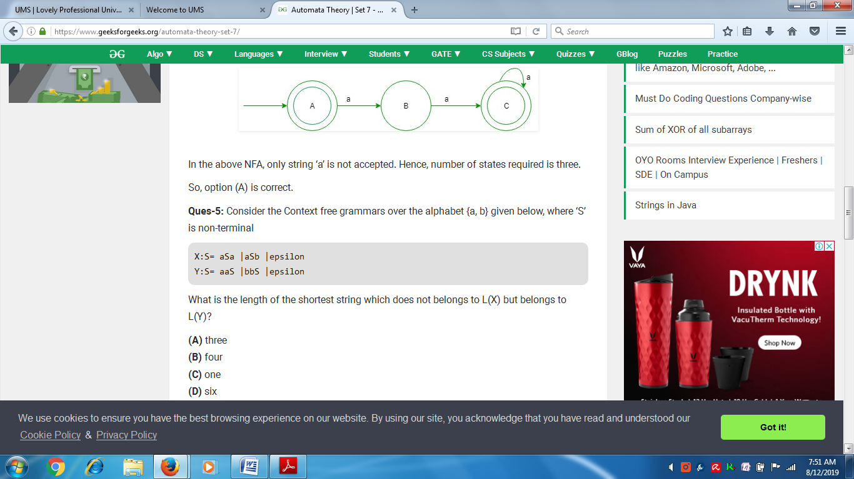

In the above NFA, only string ‘a’ is not accepted. Hence, number of states required is three.

So, option (A) is correct.

Let w be any string of length n in {a, b}*. Consider ‘L’ be the set of all strings ending with at least n a’s. What is the minimum number of states in non deterministic finite automata that accept ‘L’?

(A) (n+3)  
(B) (n+1)  
(C) n  
(D) 2n

Explanation:  
It is correct since, the minimum number of states required for NFA for ending with at least 2 a’s is (2 + 1) i.e., regular expression will be (a + b)*aa  
  
Hence, Number of states required for at least n a’s will be (n+1).

Option (B) is true.

What is the minimum number of states in deterministic finite automata (DFA) for string starting with ba2 and ending with ‘a’ over alphabet {a, b}?

(A) Ten  
(B) Nine  
(C) Eight  
(D) Six

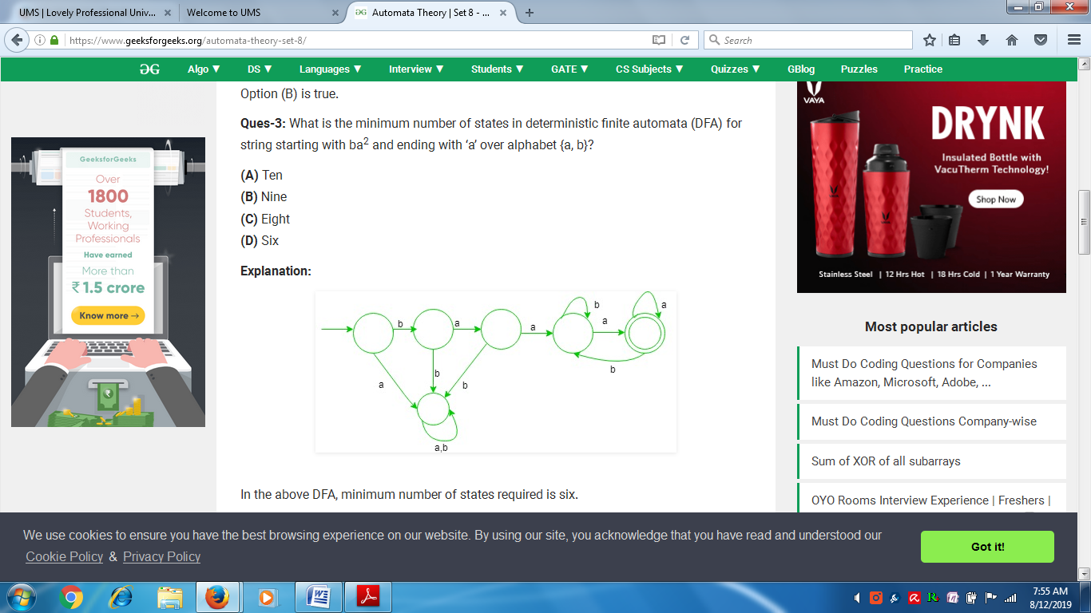

n the above DFA, minimum number of states required is six.

Option (D) is correct.

Ques-5: What is the number of states in minimal NFA(non deterministic finite automata), which accepts set of all strings in which the third last symbol is ‘a’ over alphabet {a, b}?

(A) three  
(B) four  
(C) six  
(D) five

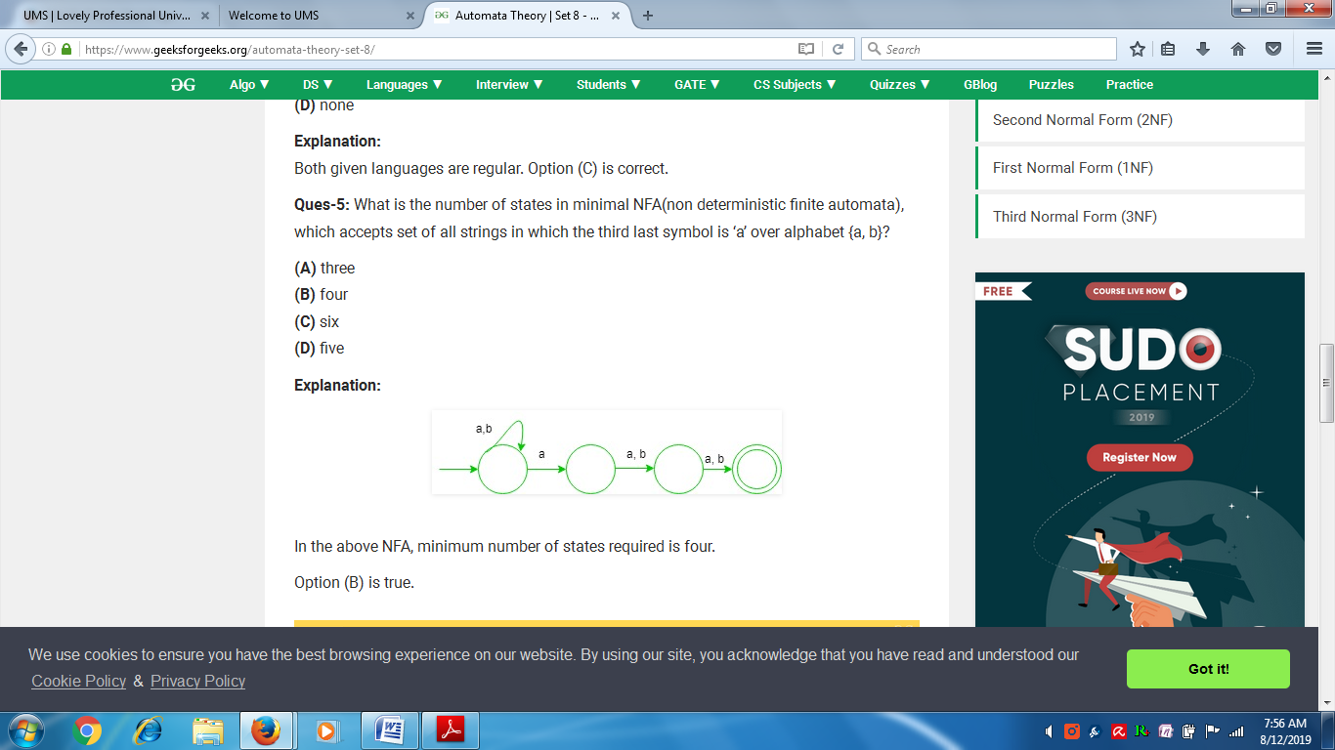

**3)Definition of a language L with alphabet {a} is given as following. L= { ank | k > 0, and n is a positive integer constant} What is the minimum number of states needed in a DFA to recognize L?**   
(A) k+1  
(B) n+1  
(C) 2n+1  
(D) 2k+1

Answer (B)

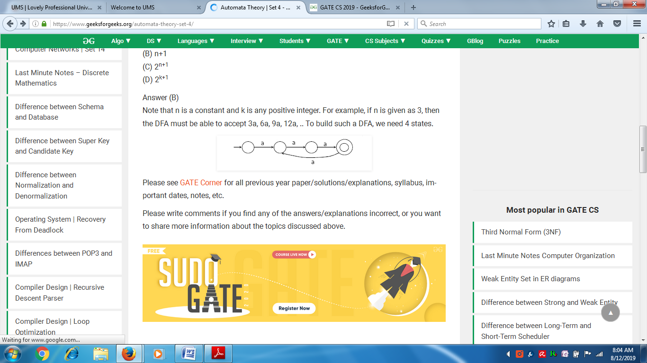

A) k+1  
(B) n+1  
(C) 2n+1  
(D) 2k+1

Answer (B)  
Note that n is a constant and k is any positive integer. For example, if n is given as 3, then the DFA must be able to accept 3a, 6a, 9a, 12a, .. To build such a DFA, we need 4 states.

**4) Let w be any string of length n is {0,1}*. Let L be the set of all substrings of w. What is the minimum number of states in a non-deterministic finite automaton that accepts L?**  
(A) n-1  
(B) n  
(C) n+1  
(D) 2n-1

Answer (C)  
We need minimum n+1 states to build NFA that accepts all substrings of a binary string. For example, following NFA accepts all substrings of “010” and it has 4 states.

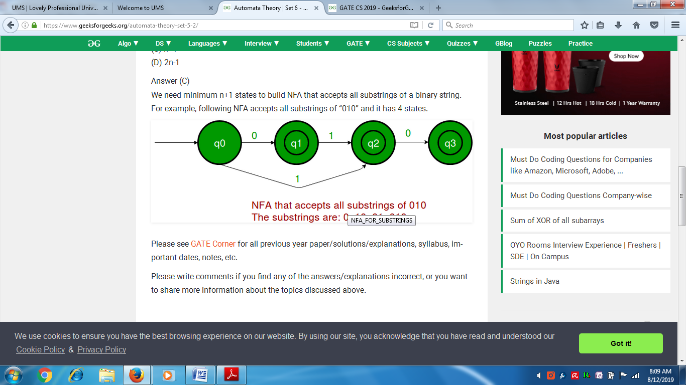

**1) The lexical analysis for a modern language such as Java needs the power of which one of the following machine models in a necessary and sufficient sense?**  
(A) Finite state automata  
(B) Deterministic pushdown automata  
(C) Non-deterministic pushdown automata  
(D) Turing machine

Answer (A)  
Lexical analysis is the first step in compilation. In lexical analysis, program is divided into tokens. Lexical analyzers are typically based on finite state automata. Tokens can typically be expressed as different regular expressions:  
An identifier is given by [a-zA-Z][a-zA-Z0-9]*  
The keyword if is given by if.  
Integers are given by [+-]?[0-9]+.

**3) A deterministic finite automation (DFA)D with alphabet ∑= {a,b} is given below**

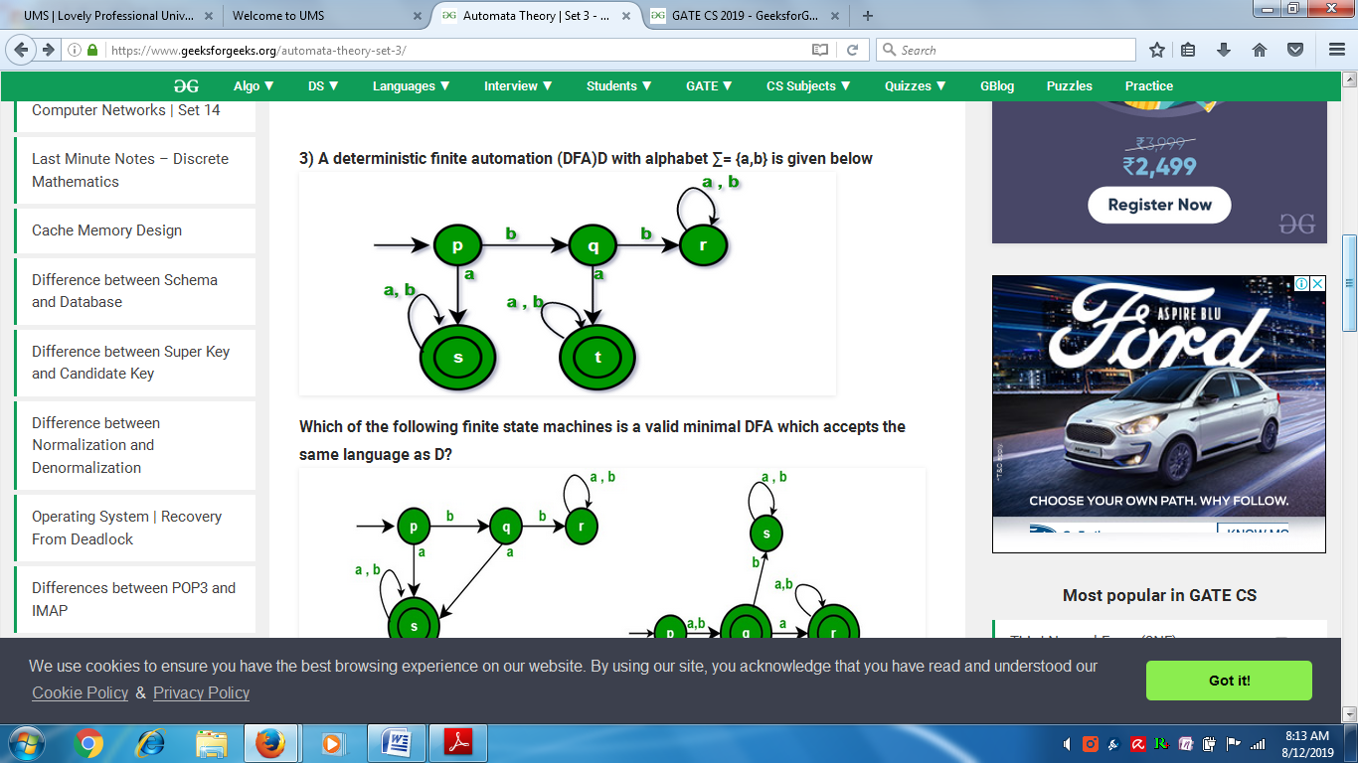

**Which of the following finite state machines is a valid minimal DFA which accepts the same language as D?**

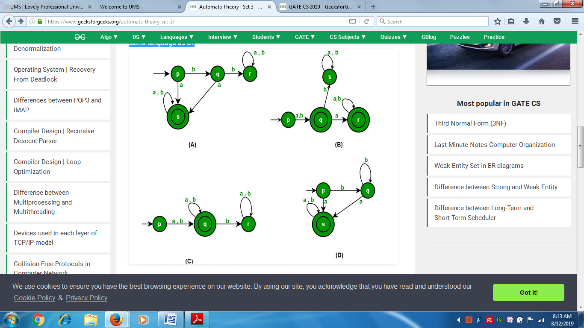

Answer (A)  
Options (B) and (C) are invalid because they both accept ‘b’ as a string which is not accepted by give DFA. D is invalid because it accepts bb+a which are not accepted by given DFA.

Following questions have been asked in GATE CS 2012 exam.

**1) What is the complement of the language accepted by the NFA shown below? Assume ∑ = {a} and ε is the empty string**

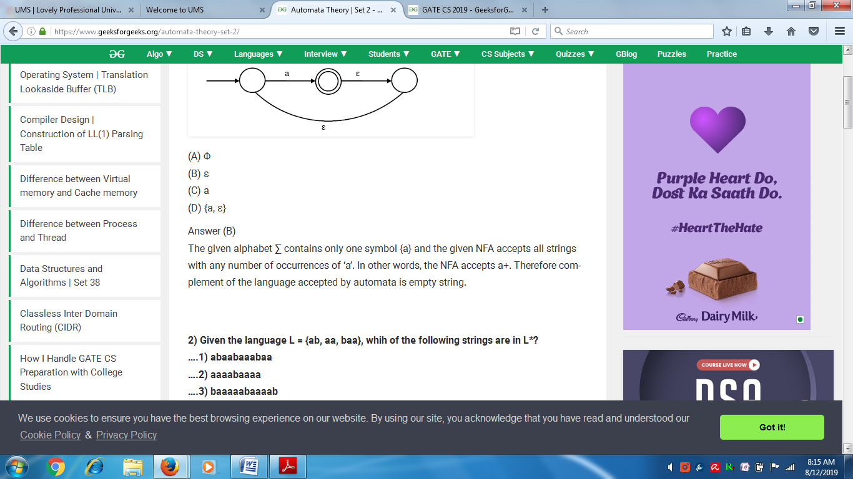

(A) Φ  
(B) ε  
(C) a  
(D) {a, ε}

Answer (B)  
The given alphabet ∑ contains only one symbol {a} and the given NFA accepts all strings with any number of occurrences of ‘a’. In other words, the NFA accepts a+. Therefore complement of the language accepted by automata is empty string.

**4) Consider the set of strings on {0,1} in which, every substring of 3 symbols has at most two zeros. For examples, 001110 and 011001 are in the language, but 100010 is not. All strings of length less than 3 are also in the language. A partially completed DFA that accepts this language is shown below.**  
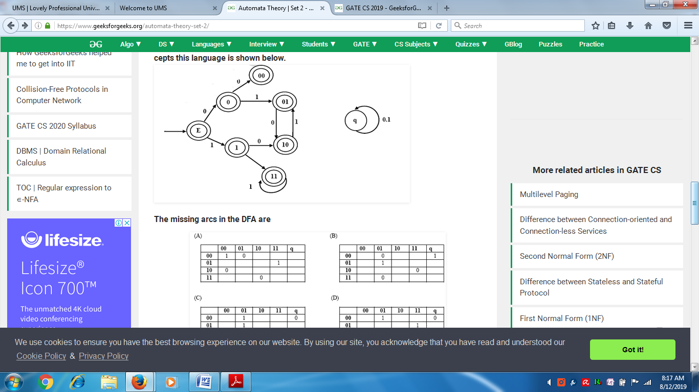

**The missing arcs in the DFA are**

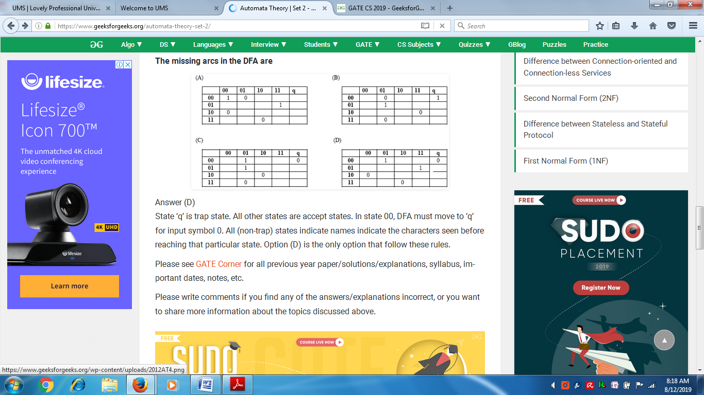



Answer (D)

State ‘q’ is trap state. All other states are accept states. In state 00, DFA must move to ‘q’ for input symbol 0. All (non-trap) states indicate names indicate the characters seen before reaching that particular state. Option (D) is the only option that follows these rules.

Ques-1: Consider the following statements:

* X: For any language either a language L or its compliment L’ must be finite.
* Y: DFA for language which contains epsilon must have initial state as final state.
* Z: Non-deterministic finite automata is more powerful than deterministic finite automata.

<https://www.sanfoundry.com/automata-theory-mcqs-finite-automata/>

2. In DFA Transition function maps.  
a) Σ * Q -> Σ  
b) Q * Q -> Σ  
c) Σ * Σ -> Q  
d) Q * Σ -> Q

Answer:d

3. Number of states require to accept string ends with 10.  
a) 3  
b) 4  
c) 5  
d) can’t be represented.

Answer :a

8. Language of finite automata is.  
a) Type 0  
b) Type 1  
c) Type 2  
d) Type 3  
View Answer

Answer:d  
Explanation: According to Chomsky classification.

Finite automata requires minimum _______ number of stacks.  
a) 1  
b) 0  
c) 2  
d) None of the mentioned  
View Answer

Answer:b  
Explanation: Finite automata doesn’t require any stack operation

13. The basic limitation of finite automata is that  
a) It can’t remember arbitrary large amount of information.  
b) It sometimes recognize grammar that are not regular.  
c) It sometimes fails to recognize regular grammar.  
d) All of the mentioned

Answer:a  
Explanation:Because there is no memory associated with automata.

15. FSM with output capability can be used to add two given integer in binary representation. This is  
a) True  
b) False  
c) May be true  
d) None of the mentioned  
View Answer

Answer:a  
Explanation: Use them as a flip flop output

5. NFA, in its name has ’non-deterministic’ because of :  
a) The result is undetermined  
b) The choice of path is non-deterministic  
c) The state to be transited next is non-deterministic  
d) All of the mentioned  
View Answer

Answer: b  
Explanation: Non deterministic or deterministic depends upon the definite path defined for the transition from one state to another or undefined(multiple paths).

1. Which of the following options is correct?  
Statement 1: Initial State of NFA is Initial State of DFA.  
Statement 2: The final state of DFA will be every combination of final state of NFA.  
a) Statement 1 is true and Statement 2 is true  
b) Statement 1 is true and Statement 2 is false  
c) Statement 1 can be true and Statement 2 is true  
d) Statement 1 is false and Statement 2 is also false  
View Answer

Answer: a  
Explanation: Statement 1 and 2 always true for a given Language.

6. Convert the NFA to DFA

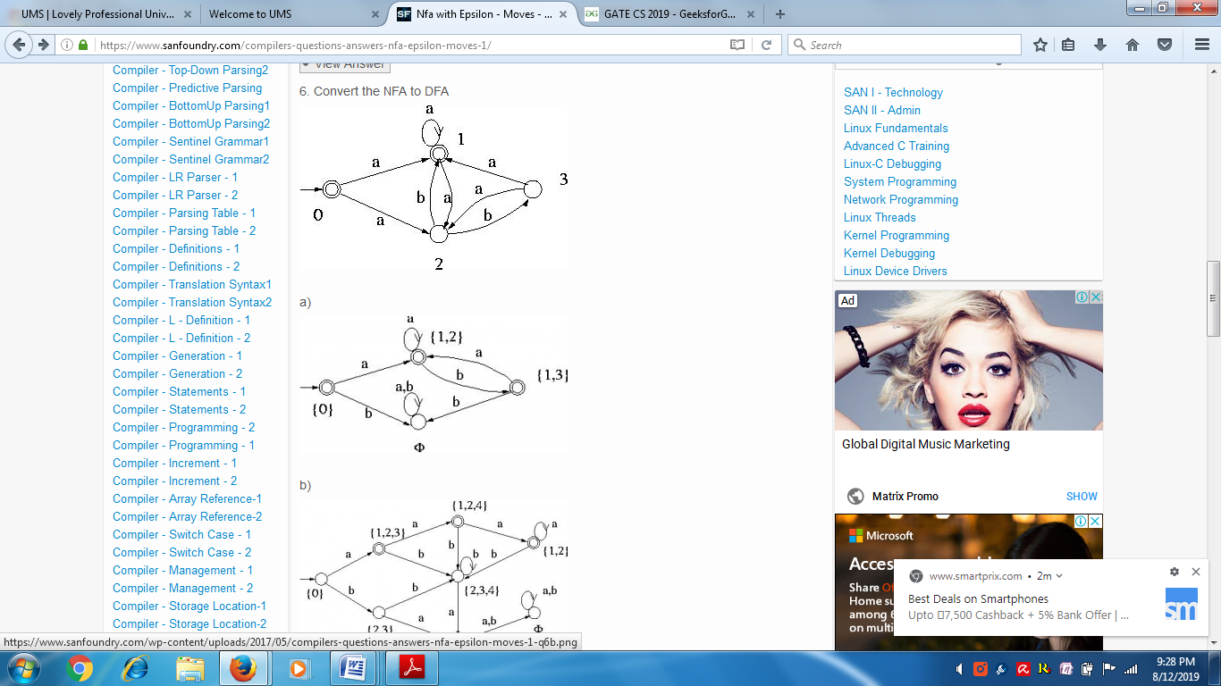





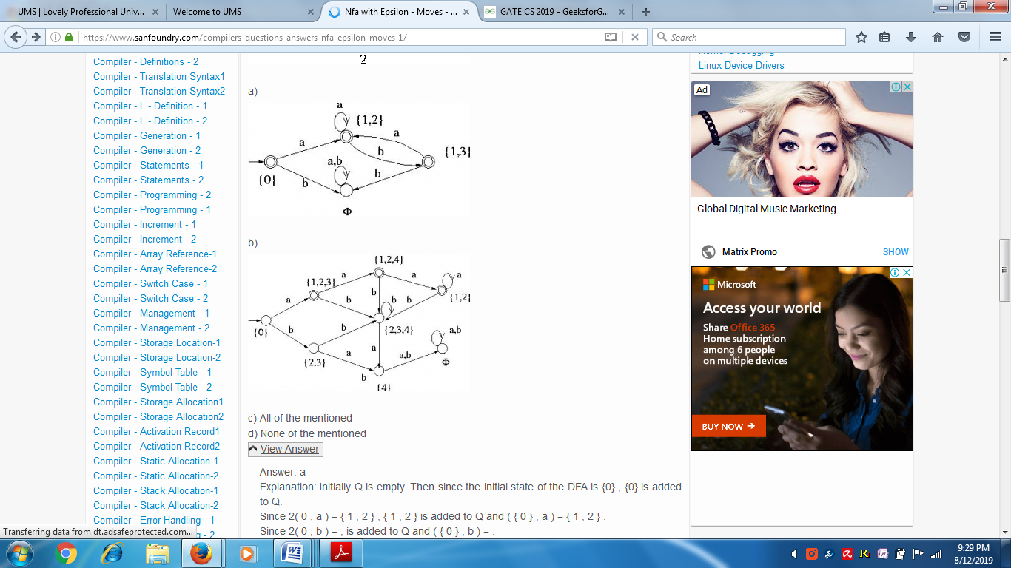

c) All of the mentioned  
d) None of the mentioned  
View Answer

Answer: a  
Explanation: Initially Q is empty. Then since the initial state of the DFA is {0} , {0} is added to Q.  
Since 2( 0 , a ) = { 1 , 2 } , { 1 , 2 } is added to Q and ( { 0 } , a ) = { 1 , 2 } .  
Since 2( 0 , b ) = , is added to Q and ( { 0 } , b ) = .  
At this point Q = { {0} , { 1 , 2 }, }. Similarly ( { 1 , 2 } , b ) = { 1 , 3 } . Hence { 1 , 3 } is added to Q . Similarly ( { 1 , 3 } , a ) = { 1 , 2 } and ( { 1 , 3 } , b ) = . Thus there are no new states to be added to Q . Since the transitions from all states of Q have been computed and no more states are added to Q, the conversion process stops here.

1. Let S and T be language over ={a,b} represented by the regular expressions (a+b*)* and (a+b)*, respectively. Which of the following is true? (GATE CS 2000)  
  
(a) ScT (S is a subset of T)  
(b) TcS (T is a subset of S)  
(c) S=T  
(d) SnT=Ø

Answer: (c).

**2) Which one of the following languages over the alphabet {0,1} is described by the regular expression: (0+1)*0(0+1)*0(0+1)*?**  
(A) The set of all strings containing the substring 00.  
(B) The set of all strings containing at most two 0’s.  
(C) The set of all strings containing at least two 0’s.  
(D) The set of all strings that begin and end with either 0 or 1.

Answer (C)  
The regular expression has two 0’s surrounded by (0+1)* which means accepted strings must have at least 2 0’s.

**3) Let L={w ∈ (0 + 1)*|w has even number of 1s}, i.e. L is the set of all bit strings with even number of 1s. Which one of the regular expression below represents L?**  
(A) (0*10*)*  
(B) 0*(10*10*)*  
(C) 0*(10*1*)*0*  
(D) 0*1(10*1*)*10*

Answer (B)  
Option (A) is incorrect because it cannot accept “110”  
Option (C) is incorrect because it accept a string with single 1.  
Option (D) is incorrect because it cannot accept 11101

4Which of the following statement(s) is/are correct?

(A) only X  
(B) only Y  
(C) only Z  
(D) all of the above.

Explanation:  
X: It is incorrect. since, a language L and its compliment can be infinite.  
Y: It is correct.since, if the language contains epsilon then its initial state must be final also, otherwise the DFA wont be able to accept epsilon.  
Z: It is incorrect. since, every language accepted by NFA is also accepted by some DFA. Hence, NFA and DFA both are equivalent in power.

Option (B) is true.

5 Which one of the following regular expression describes the language over {a, b} which consists of no pair of consecutive b’s?

(A) (a*baa*)(b + epsilon)  
(B) (a + ba)*(b + epsilon)  
(C) (a*baa*)*(b + epsilon) + a*  
(D) (a*ba*)*(b + epsilon) + a*(b + epsilon)

Explanation:

* (A) It is incorrect. since, it does not contains (a or epsilon).
* (B) It is correct. since, it contains (epsilon, a, b, ba, ab, …..), i.e., no pair of consecutive b’s.
* (C) It is incorrect. since, it does not contains ‘ab’ or ‘aab’.
* (D) It is incorrect. since, it contains ‘bb’, which is not allowed.

Option (B) is true.

6 What is the length of the shortest string not in the language over alphabet {0, 1} for regular expression given below:

1*(0 + 1)*1*

(A) seven  
(B) five  
(C) six  
(D) four

Explanation:  
Check each string generated over the alphabet {0, 1} until you reach the shortest string which is not generated by the given regular expression.  
In this case, smallest string which is not generated by the given regular expression is 0110, whose length is four.

so, option (D) is true.

7 Consider X and Y are two languages over alphabet {0, 1} represented by regular expression 0*(10*)* and (0* + 1*)* respectively. which of the following is true?

(A) X is proper subset of Y  
(B) Y is proper subset of X  
(C) X = Y  
(D) none

Explanation:  
Here,

L(X)

= 0*(10*)*

= {epsilon, 0, 1, 10, 01, 00, 11, ......}

And.

L(Y)

= (0* + 1*)*

= {epsilon, 0, 1, 10, 01, 00, 11, ....}

So, both languages are equivalent to each other.

Option (C) is true.

The Applications of these Automata are given as follows:

<https://www.sanfoundry.com/compilers-questions-answers-nfa-epsilon-moves-1/>

8. S –> aSa| bSb| a| b ;the language generated by the above grammar is the set of  
a) All palindromes.  
b) All odd length palindromes  
c) Strings beginning and ending with the same symbol  
d) All even length palindromes  
View Answer

Answer: b  
Explanation: The strings accepted by language are {a, b, aaa, bbb, aba, bab,}. All the strings are odd length palindromes.

9 Which one of the following languages over the alphabet {0, 1} is described by the regular expression: (0+1)*0(0+1)*0(0+1)*?  
a) strings with the substring 00  
b) strings with at most two 0’s  
c) strings with at least two 0’s  
d) strings beginning and ending with either 0 or 1  
View Answer

Answer: c  
Explanation: The RE having 2 0’s padded by (0+1)* which means accepted strings must have at least 2 0’s.

10.Does epsilon ring makes any change in the automata  
a) Yes  
b) No  
View Answer

Answer: b  
Explanation: It adds nothing new to the automata.

11.Which of the technique can be used to prove that a language is non regular?  
a) Ardens theorem  
b) Pumping Lemma  
c) Ogden’s Lemma  
d) None of the mentioned  
View Answer

Answer: b  
Explanation: We use the powerful technique called Pumping Lemma, for showing certain languages not to be regular. We use Ardens theorem to find out a regular expression out of a finite automaton.

12 Which of the following language regular?  
a) {aibi|i>=0}  
b) {aibi|0<i<5}  
c) {aibi|i>=1}  
d) None of the mentioned  
View Answer

Answer: b  
Explanation: Here, i has limits i.e. the language is finite, contains few elements and can be graphed using a deterministic finite automata. Thus, it is regular. Others can be proved non regular using Pumping lemma.

13. Which of the following are non regular?  
a) The set of strings in {a,b}* with an even number of b’s  
b) The set of strings in {a, b, c}* where there is no c anywhere to the left of a  
c) The set of strings in {0, 1}* that encode, in binary, an integer w that is a multiple of 3. Interpret the empty strings e as the number 0.  
d) None of the mentioned  
View Answer

Answer: d  
Explanation: All of the given languages are regular and finite and thus, can be represented using respective deterministic finite automata. We can also use mealy or moore machine to represent remainders for option c.

14. If L is DFA-regular, L’ is  
a) Non regular  
b) DFA-regular  
c) Non-finite  
d) None of the mentioned  
View Answer

Answer: b  
Explanation: This is a simple example of a closure property: a property saying that the set of DFA-regular languages is closed under certain operations.

If L is DFA-regular, L’ is  
a) Non regular  
b) DFA-regular  
c) Non-finite  
d) None of the mentioned  
View Answer

Answer: b  
Explanation: This is a simple example of a closure property: a property saying that the set of DFA-regular languages is closed under certain operations.

15. Which of the following options is incorrect?  
a) A language L is regular if and only if ~L has finite number of equivalent classes.  
b) Let L be a regular language. If ~L has k equivalent classes, then any DFA that recognizes L must have atmost k states.  
c) A language L is NFA-regular if and only if it is DFA-regular.  
d) None of the mentioned  
View Answer

Answer: b  
Explanation: Let L be a regular language. If ~L has k equivalent classes, then any DFA that recognizes L must have atleast k states.

16 Myhill Nerode does the following:  
a) Minimization of DFA  
b) Tells us exactly when a language is regular  
c) Both (a) and (b)  
d) None of the mentioned  
View Answer

Answer: c  
Explanation: In automata theory, the Myphill Nerode theorem provides a necessary and sufficient condition for a language to be regular. The Myphill Nerode theorem can be used to show a language L is regular by proving that the number of equivalence classes of RL(relation) is finite.

17. NDFAs where introduced by ____________  
a) Michael O Rabin & Dana Scott  
b) Dan Brown  
c) Sun micro system Labs  
d) SAP Labs  
View Answer

Answer: a  
Explanation: NFAs were introduced Dana Scott and Michael O. Rabin who also showed their equivalence to DFAs.

18 The regular languages are not closed under  
a) Concatenation  
b) Union  
c) Kleene star  
d) Complement  
View Answer

Answer: d  
Explanation: RE are closed under  
• Union (cf. picture)  
• Intersection  
• Concatenation  
• Negation  
• Keene closure.

19. An NFA’s transition function returns  
a) A Boolean value  
b) A state  
c) A set of states  
d) An edge  
View Answer

Answer: c  
Explanation: A transition function Δ: Q × Σ → P (Q).Where P (Q) denotes the power set of Q…

20. How many strings of length less than 4 contains the language described by the regular expression (x+y)*y(a+ab)*?  
a) 7  
b) 10  
c) 12  
d) 11  
View Answer

Answer : d  
Explanation : string of length 0 = 1  
string of length 1 = 4  
string of length 2 = 3  
string of length 3 = 3

21. Which of the following is true?  
a) (01)*0 = 0(10)*  
b) (0+1)*0(0+1)*1(0+1) = (0+1)*01(0+1)*  
c) (0+1)*01(0+1)*+1*0* = (0+1)*  
d) All of the mentioned  
View Answer

Answer : d  
Explaination : None.

22.A language is regular if and only if  
a) accepted by DFA  
b) accepted by PDA  
c) accepted by LBA  
d) accepted by Turing machine  
View Answer

Answer : a  
Explanation : All of above machine can accept regular language but all string accepted by machine is regular only for DFA.

23. Let the class of language accepted by finite state machine be L1 and the class of languages represented by regular expressions be L2 then  
a) L1<L2  
b) L1>=L2  
c) L1 U L2 = .*  
d) L1=L2  
View Answer

Answer : d  
Explanation : Finite state machine and regular expression have same power to express a language.

24. Which of the following is not a regular expression?  
a) [(a+b)*-(aa+bb)]*  
b) [(0+1)-(0b+a1)*(a+b)]*  
c) (01+11+10)*  
d) (1+2+0)*(1+2)*  
View Answer

Answer : b  
Explanation : Except b all are regular expression*

25. Regular expression are  
a) Type 0 language  
b) Type 1 language  
c) Type 2 language  
d) Type 3 language  
View Answer

Answer : a  
Explanation : According to Chomsky hierarchy .

26.Which of the following is true?  
a) Every subset of a regular set is regular  
b) Every finite subset of non-regular set is regular  
c) The union of two non regular set is not regular  
d) Infinite union of finite set is regular  
View Answer

Answer : b  
Explanation : None.

27. Regular expressions are closed under  
a) Union  
b) Intersection  
c) Kleen star  
d) All of the mentioned  
View Answer

Answer : d  
Explanation : According to definition of regular expression.

7. Myphill Nerode does the following:  
a) Minimization of DFA  
b) Tells us exactly when a language is regular  
c) Both (a) and (b)  
d) None of the mentioned  
View Answer

Answer: c  
Explanation: In automata theory, the Myphill Nerode theorem provides a necessary and sufficient condition for a language to be regular. The Myphill Nerode theorem can be used to show a language L is regular by proving that the number of equivalence classes of RL(relation) is finite.

28. Which of the following strings do not belong the given regular expression?  
(a)*(a+cba)  
a) aa  
b) aaa  
c) acba  
d) acbacba  
View Answer

Answer: d  
Explanation: The string acbacba is unacceptable by the regular expression (a)*(a+cba).

2. Let L denotes the language generated by the grammar S – OSO/00. Which of the following is true? (GATE CS 2000)  
(a) L = O  
(b) L is regular but not O  
(c) L is context free but not regular  
(d) L is not context free

Answer: (b)  
Explanation: Please note that grammar itself is not regular but language L is regular as L can be represented using a regular grammar, for example S -> S00/00.  
References:  
<http://en.wikipedia.org/wiki/Regular_grammar>

3. Consider the following two statements:  
S1: { 0^2n |n >= l} is a regu1ar language  
S2: { 0^m 0^n 0^(m+n) l m >= 1 and n >= 2} is a regu1ar language  
Which of the following statements is correct? (GATE CS 2001)  
a) Only S1 is correct  
b) Only S2 is correct  
c) Both S1 and S2 are correct  
d) None of S1 and S2 is correct

Answer: (c)  
Explanation:  
S1 can be written as (00)^n where n >= 1. And S2 can be written as (00)^(m+n) where m >=2 and n >= 1. S2 can be further reduced to (00)^x where x >= 3.  
We can easily write regular grammars for both S1 and S2.  
G1 -> G100/00 (For S1)  
G2 -> G200/000000 (For S2)

Ques-1: Which one of the following language is Regular?

(A) {wxwR | w,x ∈ (a+b)+}  
(B) {wxwR | w ∈ (a+b)*, x ∈ {a,b}}  
(C) {wwRx | w,x ∈ (a+b)+}  
(D) {wwR | w ∈ (a+b)*}

Explanation:

* (A) It is correct, since this language can form regular expression which is {{ a(a + b)+a } + {b(a + b)+b}}, i.e., start and end with same symbol.
* (B) It is deterministic context free language since, string before and and after ‘x’ are same so, it is matched.
* (C) It cannot be regular since, wwR is done at first which requires comparison which cannot be done via finite automata.
* (D) It is also not regular since, comparison is required.

Option (A) is true.

Ques-4: Consider the following statements:

S1 = {(an)m | n = 0}

S2 = {anbn | n>=1} U {anbm | n>=1, m>=1}

Which one of the following is regular?

(A) only S1  
(B) only S2  
(C) both S1 and S2  
(D) none

**Explanation:**  
Both given languages are regular. Option (C) is correct.

**1) S –> aSa| bSb| a| b ;The language generated by the above grammar over the alphabet {a,b} is the set of**  
(A) All palindromes.  
(B) All odd length palindromes.  
(C) Strings that begin and end with the same symbol  
(D) All even length palindromes.

Answer (B)  
The strings accepted by language are {a, b, aaa, bbb, aba, bab, ..}. All of these strings are odd length palindromes.

**1) Let P be a regular language and Q be context-free language such that Q ⊆ P. (For example, let P be the language represented by the regular expression p*q* and Q be {pnqn|n ∈ N}). Then which of the following is ALWAYS regular?**  
(A) P ∩ Q  
(B) P – Q  
(C) ∑* – P  
(D) ∑* – Q

Answer (C)  
The expression ∑* – P represents complement of P which is a regular language. Complement of Regular languages is also regular. Then a DFA that accepts the complement of L, i.e. ∑* – L, can be obtained by swapping its accepting states with its non-accepting states.

**2) Given the language L = {ab, aa, baa}, whih of the following strings are in L*?**  
**….1) abaabaaabaa**  
**….2) aaaabaaaa**  
**….3) baaaaabaaaab**  
**….4) baaaaabaa**  
(A) 1, 2 and 3  
(B) 2, 3 and 4  
(C) 1, 2 and 4  
(D) 1, 3 and 4

Answer (C)  
Any combination of strings in set {ab, aa, baa} will be in L*.  
….**1)** “abaabaaabaa” can be partitioned as a combination of strings in set {ab, aa, baa}. The partitions are “ab aa baa ab aa”  
….**2)** “aaaabaaaa” can be partitioned as a combination of strings in set {ab, aa, baa}. The partitions are “aa ab aa aa”  
….**3)** “baaaaabaaaab” cannot be partitioned as a combination of strings in set {ab, aa, baa}  
….**4)** “baaaaabaa” can be partitioned as a combination of strings in set {ab, aa, baa}. The partitions are “baa aa ab aa”

3. Which of the following relates to Chomsky hierarchy?  
a) Regular<CFL<CSL<Unrestricted  
b) CFL<CSL<Unrestricted<Regular  
c) CSL<Unrestricted<CF<Regular  
d) None of the mentioned  
View Answer

Answer: a  
Explanation: The chomsky hierarchy lays down the following order: Regular<CFL<CSL<Unrestricted

8. Which of the following strings is not generated by the given grammar:  
S->SaSbS|e  
a) aabb  
b) abab  
c) abaabb  
d) None of the mentioned  
View Answer

Answer: d  
Explanation: All the given options are generated by the given grammar. Using the methods of left and right derivations, it is simpler to look for string which a grammar can generate.

If L and L' are recursively enumerable, then L is

|  |  |
| --- | --- |
| A | Regular |
| B | context-free |
|  | context-sensitive |
|  |  |

. The class of recursively enumerable language is known as:  
a) Turing Class  
b) Recursive Languages  
c) Universal Languages  
d) RE  
View Answer

Answer: d  
Explanation: RE or recursively ennumerable is only called the class of recursively ennumerable language.

. Which of the following statements are false?  
a) Every recursive language is recursively ennumerable  
b) Recursively ennumerable language may not be recursive  
c) Recursive languages may not be recursively ennumerable  
d) None of the mentioned  
View Answer

Answer: c  
Explanation: Every recursive language is recursively ennumerable but there exists recursively ennumerable languages that are not recursive. If L is accepted by a Non deterministic TM T, and every possible sequence of moves of T causes it to halt, then L is recursive.

4. Choose the correct option:  
Statement: If L1 and L2 are recursively enumerable languages over S, then the following is/are recursively enumerable.  
a) L1 U L2  
b) L2 ∩ L2  
c) Both (a) and (b)  
d) None of the mentioned  
View Answer

Answer: c  
Explanation: Both the union and intersection operations preserve the property of recursive ennumerablity(Theorem).

5. If L is a recursive language, L’ is:  
a) Recursive  
b) Recursively Ennumerable  
c) Both (a) and (b)  
d) None of the mentioned  
View Answer

Answer: c  
Explanation: If T is a turing machine recognizing L, we can make it recognize L’ by interchanging the two outputs. And every recursive language is recursively ennumerable.

6. Choose the appropriate option:  
Statement: If a language L is recursive, it is closed under the following operations:  
a) Union  
b) Intersection  
c) Complement  
d) All of the mentioned  
View Answer

Answer: d  
Explanation: The closure property of recursive languages include union, intersection and complement operations.

. A recursively ennumerable language L can be recursive if:  
a) L’ is recursively ennumerable  
b) Every possible sequence of moves of T, the TM which accept L, causes it to halt  
c) Both (a) and (b)  
d) None of the mentioned  
View Answer

Answer: c  
Explanation: Theorem- If L is a recursively ennumerable language whose complement is recursively ennumerable, then L is recursive.

3. A language is regular if and only if  
a) accepted by DFA  
b) accepted by PDA  
c) accepted by LBA  
d) accepted by Turing machine  
View Answer

Answer : a  
Explanation : All of above machine can accept regular language but all string accepted by machine is regular only for DFA.

4. Regular grammar is  
a) context free grammar  
b) non context free grammar  
c) english grammar  
d) none of the mentioned  
View Answer

Answer : a  
Explanation : Regular grammar is subset of context free grammar.

5. Let the class of language accepted by finite state machine be L1 and the class of languages represented by regular expressions be L2 then  
a) L1<L2  
b) L1>=L2  
c) L1 U L2 = .*  
d) L1=L2  
View Answer

Answer : d  
Explanation : Finite state machine and regular expression have same power to express a language.

7. Regular expression are  
a) Type 0 language  
b) Type 1 language  
c) Type 2 language  
d) Type 3 language  
View Answer

Answer : a  
Explanation : According to Chomsky hierarchy

S → SS S → λ S → aSb S → bSa which type of grammar is it?  
a) Linear  
b) Nonlinear  
c) Both of the mentioned  
d) None of the mentioned  
View Answer

Answer: a  
Explanation: Grammar is non-linear because one of the rules (the first one) has two non-terminals on the right-hand side.

5. S → abS S → a is which grammar  
a) Right Linear Grammar  
b) Left Linear Grammar  
c) Right & Left Linear Grammar  
d) None of the mentioned  
View Answer

Answer: a  
Explanation: grammars in which all of the rules contain only one non-terminal on the left-hand side, and where in every case that non-terminal is the first symbol are called right Linear.

6. What are the two types of Linear Grammar?  
a) Right Linear  
b) Left Linear  
c) None of the mentioned  
d) Right & Left Linear  
View Answer

Answer: d  
Explanation: Linear grammar is of 2 types Left and Right Linear Grammar

8. Which Type of Grammar is it?  
S → Aa A → Aab | λ  
a) Right Linear  
b) Left Linear  
c) None of the mentioned  
d) Right & Left Linear  
View Answer

Answer: b  
Explanation: In this case they both correspond to the regular expression (ab)*a

* Accepts a string a followed by b{a,b}
* Accepts a string containing even number of a’s and any number of b’s {a,b}
* Accepts a string containing 2 consectutive a’s followed by 2 consectutive b’s {a,b}
* Accepts a string that doesnot contain 3 consecutive a’s {a,b}
* Accepts a string that contains even number of 0’s and even number of 1’s
* Ends with one b and even number of a’s
* Accepts string aab
* Accepts string that ends b not aa
* Accepts a string that must not end withaa

